

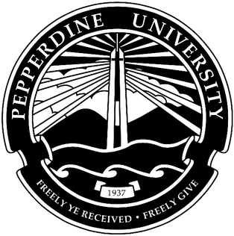

**Graduate School of Education and Psychology**

**And**

**Seaver College**

**Teacher Preparation Program**

**Program Review**

**Evidence & Documentation Report Submitted to**

**California Commission on Teacher Credentialing**

**October 2019**

**Contact Information:**

**Helen Easterling Williams, Dean**

**Graduate School of Education and Psychology**

310-568-5600

Table of Contents

1. Program Summary 3

2.1 Organizational Structure 8

3.2 Annotated Faculty list with links to Faculty Vitae and Syllabi 11

3.3 Published Adjunct Experience and Qualifications Requirements 11

4. Course Sequence. Exhibit 4.1 Published course sequence from Course Catalog. 12

Graduate Pathway 12

Undergraduate Pathway: 14

5. Course Matrix 17

6. Clinical Practice and Fieldwork 18

1. Table of hours. Undergraduate Pathway 18

1. Table of hours. Graduate Pathway. 20

2. Memorandum of Understanding. 20

3. Training Materials. Here are samples of our training materials, for both Pathways, Graduate & Undergraduate: 35

4. Placement Spreadsheet/Table 48

5. Published Manuals or Handbooks or Advising Materials (links) 54

6.6 Syllabi 56

Undergraduate Pathway 56

Graduate Pathway Syllabi 74

6.7 Clinical Practice Assessment Instruments 98

7. Credential Recommendation 104

7.1 Description of the process ensuring appropriate recommendation 104

7.1.1. Candidate Progress Monitoring Documents 105

# Program Summary

**Program Design**

The Pepperdine University Teacher Preparation Program (TPP) is led by the Program Director. The program has an Undergraduate Pathway and Graduate Pathway which are under the Program Director’s leadership. Both the Undergraduate Pathway and Graduate Pathway have: Pathway Coordinators, Directors of Clinical Placements, and a body of faculty. There is also support personnel, an accreditation liaison, and a Certification Manager who oversees the credentialing process, who communicate regularly with both pathways.

Within the Undergraduate Pathway and Graduate Pathway, communications flow regularly between all personnel and the Program Director. When communicating with the institution, each pathway reaches out to its respective Associate or Divisional Dean. To ensure that the Undergraduate Pathway and Graduate Pathway are in alignment with teaching standards and expectations, the Program Director arranges meetings where all TPP personnel are present once a semester.

**Coursework**

The general coursework overview of the Undergraduate Pathway and Graduate Pathway is to begin with courses in literacy and social foundations while doing the first term of clinical experience, which mostly consists of classroom observations. In the second phase of clinical experience, which involves partial takeover of the classroom, Teacher Candidates (TCs) take courses on teaching methods and teaching English learners. In the final term of clinical experience, TCs transition to full-time student teaching and also conclude with courses in advanced teaching methods and teaching students with exceptional needs.

For the Undergraduate Pathway and Graduate Pathway, one modification in the past two years was adding a course on teaching students with exceptional needs in order to be in compliance with CTC standards. In the Undergraduate Pathway, there were partnerships established with three professional development schools which contribute to education coursework and research projects within the program. In addition, Liberal Arts majors who pursued the Multiple Subject credential saw a modification of coursework and major requirements such that more teacher education courses could count towards their major. As such, a “Liberal Arts for Education” major with a specialized senior seminar was formed. In the Graduate Pathway, course delivery transitioned from a 75:25 face-to-face to online ratio to 65:35. A course on action research was also replaced by a course on researching contemporary issues (MATP 699). Finally, the teaching methods course was split into one for Multiple Subject TCs and one for Single Subject TCs as opposed to a general group that periodically split into subject-specific groups. When it comes to stakeholder input, the Directors of Field Experience reach out to partner schools and districts as needed. If there is a request extending beyond field experience, it is forwarded to the Program Director.

**Course of Study (Curriculum and Field Experience)**

In general, the Undergraduate Pathway and Graduate Pathway of the Pepperdine University TPP are both designed such that the three phases of fieldwork (Clinical Experience 1, 2, and 3), which correspond to three field placements specific to the TC’s subject area, synergize with coursework.

In the first term of clinical experience, which focuses on observations, coursework is coordinated such that knowledge of educational foundations, human development, literacy, and instructional design is a prerequisite or corequisite. This way, TCs have initial exposure to fundamental understandings in teaching. They will also use their observations to note key ideas in these courses. By doing so, TCs gain a stronger understanding of how teachers apply these fundamental understandings to the classroom effectively.

The next two terms of clinical experience, which introduce classroom takeover, are coordinated with courses in teaching methods, English learners, and students with exceptional needs. Concerning teaching methods, these courses deal more directly with practices TCs should be implementing as they adjust to managing their own classroom. By the end of fieldwork, TCs should have practiced not only the most effective teaching strategies for a classroom but also techniques for differentiated instruction. Likewise, opportunities to practice teaching methods and differentiation strategies allow TCs to bring their experiences back to their courses so they can debrief with faculty and find new ways to improve their practices.

**Undergraduate Pathway**

The Undergraduate Pathway is split into four phases. TCs work on their bachelor’s degree and their teaching credential simultaneously and can finish both in 4 to 4 ½ years. The course sequence for the Undergraduate Pathway is shown in the table below.

|  |  |
| --- | --- |
| **Undergraduate Pathway** | |
| Phase  **1** | **EDUC 251:** Human Development (3 units)  **EDUC 461:** Instructional Design (3 units)  **EDUC 462:** Educational Foundations (3 units) |
| Phase  **2** | **EDUC 463 (Multiple) or 464 (Single):** Literacy Theory and Methods (4 units)  **EDUC 501:** Clinical Experience 1 (0 units)  **EDUC 465:** Teaching English Learners (4 units)  **EDUC 466:** Teaching Students with Exceptional Needs (3 units) |
| Phase  **3** | *(The Basic Skills requirement and Subject Matter Competency must be fulfilled before beginning this term. Candidates doing the English Subject Matter Preparation Program must have verified progress in good academic standing)*  **EDUC 510 (Multiple) or 520 (Single):** Teaching and Content Area Methods (4 units)  **EDUC 521:** Clinical Experience 2 (2 units) |
| **Phase 4** | **EDUC 530:** Advanced Teaching Methods (4 units)  **EDUC 531:** Clinical Experience 3 (4 units) |

**Graduate Pathway**

The Graduate Pathway is split into three terms which take approximately 11 months to complete. The course sequence for the Graduate Pathway is shown in the table below.

|  |  |
| --- | --- |
| **Graduate Pathway** | |
| **Term 1** | **MATP 624:** Education Foundations, Equity, and Social Justice (3 units)  **MATP 610:** Instructional Design (3 units)  **MATP 620:** Literacy Theory and Methods (4 units)  **MATP 681:** Clinical Experience 1 (2 units) |
| **Term 2** | *(The Basic Skills requirement and Subject Matter Competency must be fulfilled before beginning this term)*  **MATP 601:** Human Development in Teaching (3 units)  **MATP 630:** Teaching English Learners (3 units)  **MATP 682:** Clinical Experience 2 (2 units)  **MATP 671 (Multiple) or 673 (Single)**: Developing Teaching Methods (3 units) |
| **Term 3** | **MATP 699:** Contemporary Issues in Education (3 units)  **MATP 683:** Clinical Experience 3 (2 units)  **MATP 661:** Teaching Students with Exceptional Needs (3 units)  **MATP 675 (Multiple) or 677 (Single):** Advanced Teaching Methods (3 units) |

All of the requirements for the Graduate Pathway also apply to the University Intern program.

**Assessment and Evaluation of Candidates**

In the Undergraduate Pathway and Graduate Pathway, the frequency and type of clinical practice evaluation depends on the clinical experience course a TC is enrolled in. In Clinical Experience 2, TCs must upload lesson plans which are carried out during student teaching throughout the term. One is peer-reviewed, one is observed and reviewed by the mentor teacher, and one is observed and reviewed by faculty, and the rest are solely reviewed by faculty. There are also reoccurring visits from University Field Supervisors (UFSs) who, alongside with mentor teachers, will observe class sessions and provide feedback on teaching practices and lesson planning. In Clinical Experience 3, TCs are required to complete four weeks of full take-over. Throughout the semester, UFSs come eight times to observe, evaluate, and support TCs in their placements. TCs have access to evaluation forms so they can see how faculty, mentor teachers, and university field supervisors evaluate their teaching. Results are all accessible through LiveText by Watermark.

In addition to clinical practice visits and evaluations, TCs are assessed in their coursework through a variety of measures. They consist of written assignments such as reflections, papers, research projects, and case studies as well as presentations and class participation in each course. When completing the edTPA, TCs are also assessed on how thoroughly they complete their tasks in a timely manner. TCs are informed of how they will be assessed through course syllabi. Faculty make sure to model examples of effective teaching and assignment completion so that TCs can have a clearer understanding of how they can meet program expectations.

In addition to TCs’ coursework, the Certification Manager monitors progress TCs make as they satisfy credential-related requirements and exams. Since TCs who struggle to pass the CSET are not allowed to proceed into the second term of Clinical Experience, they are notified early on to discuss testing challenges with an advisor.

Exhibit 1.1.1 Table depicting location, delivery models, and pathways

|  |  |  |
| --- | --- | --- |
| **Location** | **Delivery Model** | **Pathway** |
| Malibu | In-Person | Traditional Student Teaching, Undergraduate |
| West Los Angeles | Hybrid (65:35 in-person: online) | Traditional Student Teaching, Graduate |
| West Los Angeles | Hybrid (65:35 in-person: online) | Intern, Graduate |
| Calabasas | Hybrid (65:35 in-person: online) | Traditional Student Teaching, Graduate |
| Calabasas | Hybrid (65:35 in-person: online) | Intern, Graduate |

# Organizational Structure

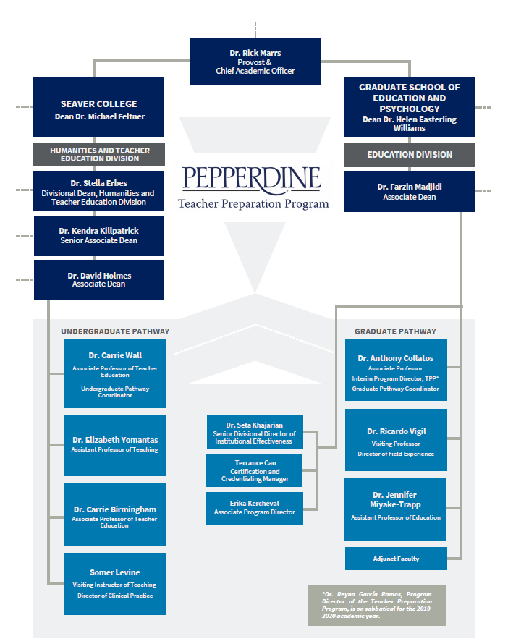

3.1 Faculty Qualifications. Faculty Distribution Table that provides an overview of faculty.

|  |  |
| --- | --- |
| **Name** | **Status** |
| Amparan, Antonio | Adjunct |
| Arrechiga, Eva | Adjunct |
| Blas, Michelle | Adjunct |
| Coronel, Jacobo | Adjunct |
| Cortez-Covarrubias, Elva | Adjunct |
| Franzen, Jessica | Adjunct |
| Gonzalez, Jeremiah | Adjunct |
| Green, Joseph | Adjunct |
| Higuchi, Dora | Adjunct |
| Hong, Sue Jean | Adjunct |
| Hubbard Braddell, Rachel | Adjunct |
| McKinstry, Elizabeth | Adjunct |
| Mumolo, Shannon | Adjunct |
| Rawn, Peggy | Adjunct |
| Roberson, Ben | Adjunct |
| Roper, Cherise | Adjunct |
| Toyoda-Smart, Kumi | Adjunct |
| Vela, Claudia | Adjunct |
| Vollmer, Donna | Adjunct |
| Wedeen, Robbie | Adjunct |
| Williams, Aleta | Adjunct |
| Wright, Maria | Adjunct |
| Birmingham, Carrie | Full-Time |
| Cain, Ebony | Full-Time |
| Collatos, Anthony | Full -Time |
| Erbes, Stella | Full-Time |
| Garcia-Ramos, Reyna | Full-Time |
| Gose, Michael | Full-Time |
| Levine, Somer | Full-Time |
| Miyake-Trapp, Jennifer | Full-Time |
| Mordechay, Kfir | Full-Time |
| Vigil, Ricardo | Full-Time |
| Wall, Carrie | Full-Time |
| Yomantas, Elizabeth | Full-Time |

|  |  |  |
| --- | --- | --- |
| Total Full-time 12 | Total Adjunct 22 | Vacancies: Zero for Full-time Openings |

## 

# 3.2 Annotated Faculty list with links to Faculty Vitae and Syllabi

[Faculty CV and Syllabi](https://docs.google.com/a/pepperdine.edu/viewer?a=v&pid=sites&srcid=cGVwcGVyZGluZS5lZHV8cGVwcGVyZGluZS10cHAtLS1jdGMtYWNjcmVkaXRhdGlvbi12aXNpdC1zaXRlfGd4OjYzODBiZDQxZjUzMjA4MTE)

# 3.3 Published Adjunct Experience and Qualifications Requirements

[Adjunct Experience Requirement](https://docs.google.com/a/pepperdine.edu/viewer?a=v&pid=sites&srcid=cGVwcGVyZGluZS5lZHV8cGVwcGVyZGluZS10cHAtLS1jdGMtYWNjcmVkaXRhdGlvbi12aXNpdC1zaXRlfGd4OjNjNWNiMTFlNjM1MzllOTA)

# Course Sequence. Exhibit 4.1 Published course sequence from Course Catalog.

## Graduate Pathway

The Graduate Pathway course sequence can be seen here, in the TC Handbook, and other printed materials:

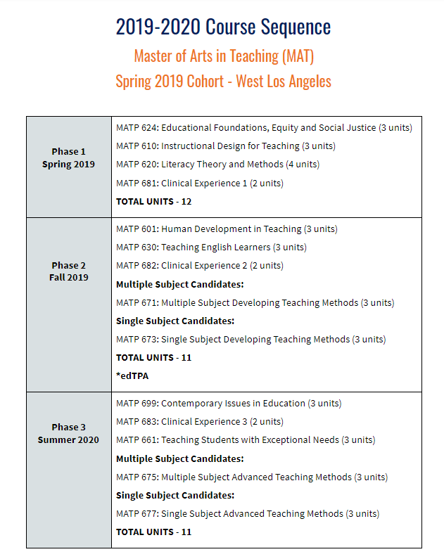

The full list of the Course Requirement can be found on p. 95 of the GSEP Academic Catalog, <https://gsep.pepperdine.edu/content/updated-academic-catalog-2019-2020.pdf> a snapshot is provided:

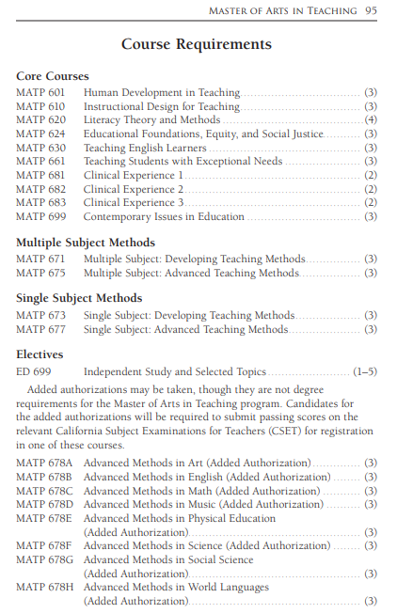

## Undergraduate Pathway:

TCs in the undergraduate pathway complete 34 units of professional education courses, divided into eight academic courses and three clinical experience courses. Because undergraduates are working on their bachelor's degree and their teaching credential simultaneously, and because they enter the program at different times in their undergraduate careers, they take the eight courses in the same order generally but not exactly. The course sequence can be found on p. 233 of Seaver’s Academic Catalog, <https://seaver.pepperdine.edu/academics/content/2019-seaver-catalog.pdf>, a snapshot is provided:

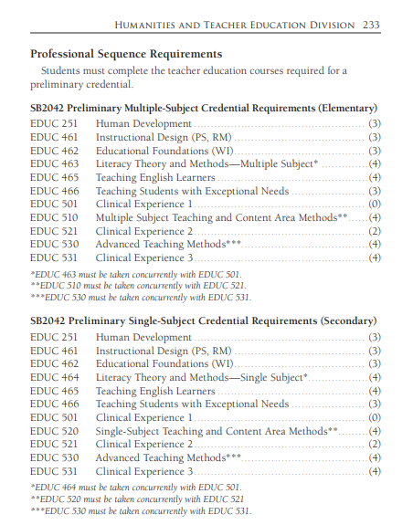

Three courses are designed to be taken at the beginning of the program by all TCs: Human Development (EDUC 251), Instructional Design (EDUC 461), and Educational Foundations (EDUC 462). Instructional Design includes 20 hours of observation fieldwork in an elementary school, and Educational Foundations includes 20 hours of observation fieldwork in a middle or high school. These courses are also part of the liberal arts for education major, so they are taken by undergraduates in this major who may or may not continue on to earn a teaching credential in their undergraduate program. These three courses are three units each currently. They had been four units for many years, but they were reduced to three units beginning in fall 2018 to make room for a new course, Teaching Students with Exceptional Needs (EDUC 466), which will also be three units.

Four courses are designed to be taken in the undergraduate’s middle semesters in the program.

|  |  |
| --- | --- |
| Multiple Subject | Single Subject |
| Literacy Theory and Methods for Multiple Subject (EDUC 463, 4 units) | Literacy Theory and Methods for Single Subject (EDUC 464, 4 units) |
| Clinical Experience 1 (EDUC 501, 0 units) | |
| Teaching English Learners (EDUC 465, 4 units) | |
| Teaching Students with Exceptional Needs (EDUC 466, 3 units)* | |

*to be taught the first time in spring 2020

Four courses—two academic courses and two clinical experience courses—complete the undergraduate’s course sequence.

|  |  |
| --- | --- |
| Multiple Subject | Single Subject |
| Teaching and Content Area Methods for Multiple Subject (EDUC 510, 4 units) | Teaching and Content Area Methods for Single Subject (EDUC 520, 4 units) |
| Clinical Experience 2 (EDUC 521.01, 2 units) | Clinical Experience 2 (EDUC 521.02, 2 units) |
| Advanced Teaching Methods (EDUC 530, 4 units) | |
| Clinical Experience 3 (EDUC 531, 4 units) | |

The clinical experience sequence is taken concurrently with academic courses, as indicated in the chart above. Clinical Experience 1 consists of 50 hours of observation/participation taken concurrently with EDUC 463/464. Clinical Experience 2 consists of 160 hours of student teaching taken concurrently with EDUC 510/520. Clinical Experience 3 consists of a full semester of full-time student teaching taken concurrently with EDUC 530.

# Course Matrix

5.1 Course matrix with links to specific activities within the syllabi that provide documentation of Introduction (I), Practice (P), and Assessment (A) of TC competencies. Assessment (A) should link to the assessments used to determine competence.

[Course Matrix](https://docs.google.com/a/pepperdine.edu/viewer?a=v&pid=sites&srcid=cGVwcGVyZGluZS5lZHV8cGVwcGVyZGluZS10cHAtLS1jdGMtYWNjcmVkaXRhdGlvbi12aXNpdC1zaXRlfGd4OjFjNTc1NzBiYjhlZTQ2MDc)

# Clinical Practice and Fieldwork

## Table of hours. Undergraduate Pathway

**Hour Totals:** For all courses, students turn in a signed hour log to their course professor.  The purpose of the signed hour log is to document the time they spend in the classroom throughout the semester.  Throughout the undergraduate pathway, TCs complete a total of **775 hours** including the observation/participation hours.  Excluding the observation/participation hours, TCs complete **735 hours.**

**Observation Participation**

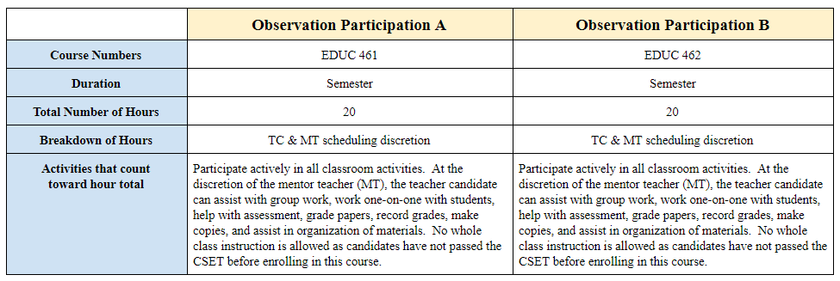

**Clinical Experiences**

|  |  |  |  |
| --- | --- | --- | --- |
|  | **Clinical Experience 1** | **Clinical Experience 2** | **Clinical Experience 3** |
| **Course Numbers** | EDUC 463/501 (MS)  EDUC 464/501 (SS) | EDUC 510/521 | EDUC 530/531 |
| **Duration** | Semester | Semester | Semester |
| **Total Number of Hours** | 50 | 160 | 525 |
| **Breakdown of Hours** | TC & MT scheduling discretion | TC & MT scheduling discretion | 72 days of student teaching  7 hours per day |
| **Activities that count  toward hour total** | Participate actively in all classroom activities. At the discretion of the  mentor teacher (MT), the teacher candidate can assist with group work, work one-on-one with students, help with assessment, grade papers, record grades, make copies, and assist in organization of materials.  No whole class instruction is allowed as candidates have not passed the CSET before enrolling in this course. | Participate actively in all classroom activities. (e.g., can assist with group work, work one-on-one with students, help with assessment, grade papers, record grades, make copies, and assist in classroom organization.)  Whole class instruction for eight formal lessons (6 observed by UFS) is required. Each lesson includes a formal lesson plan. | Attend all faculty meetings, IEP meetings, parent/teacher conferences, Back-to-School nights, professional development opportunities, and any other faculty duties with permission from the MT. Candidates gradually work towards a minimum of four weeks of full takeover. Candidates take on responsibilities including lesson planning, teaching, assessment, grading, recording grades, and organizing lesson materials. Candidates are observed eight times by a University Field Supervisor (UFS). |

## Table of hours. Graduate Pathway.

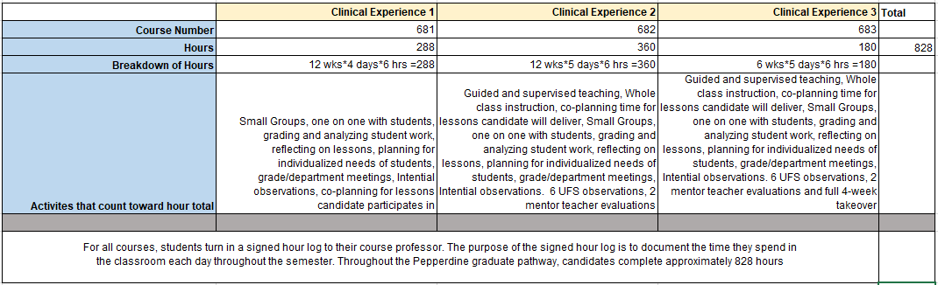

## Memorandum of Understanding.

Samples of MOU’s are included here below:

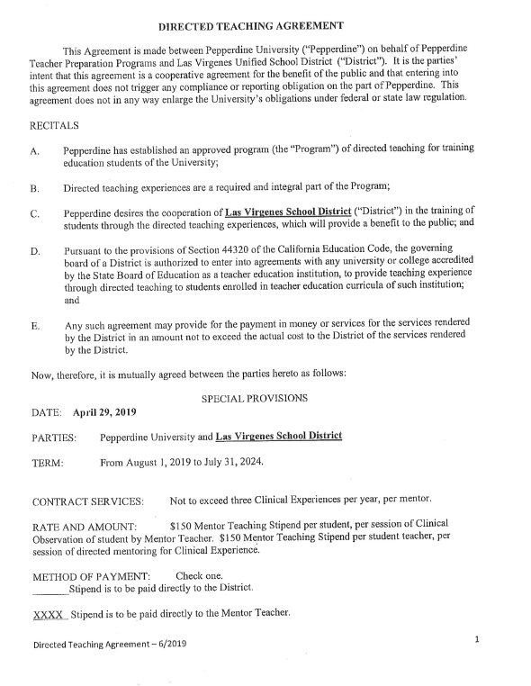 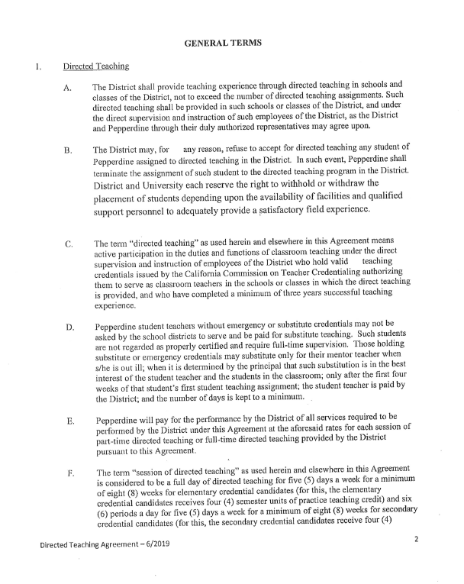

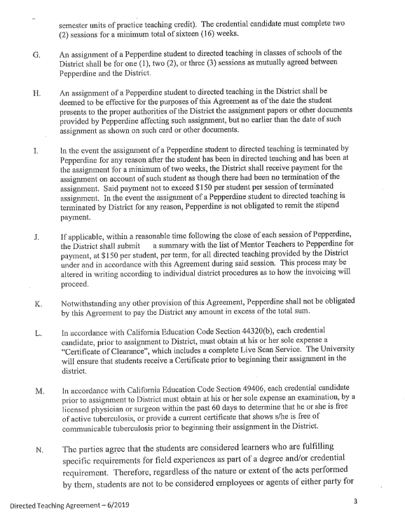 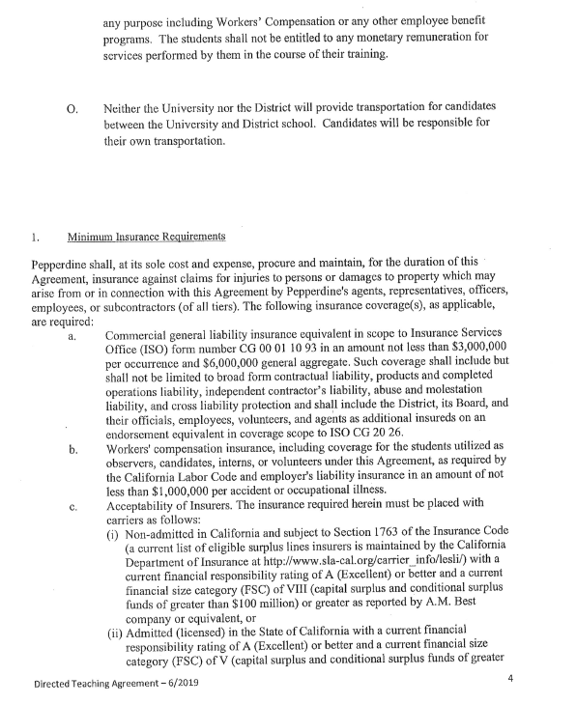 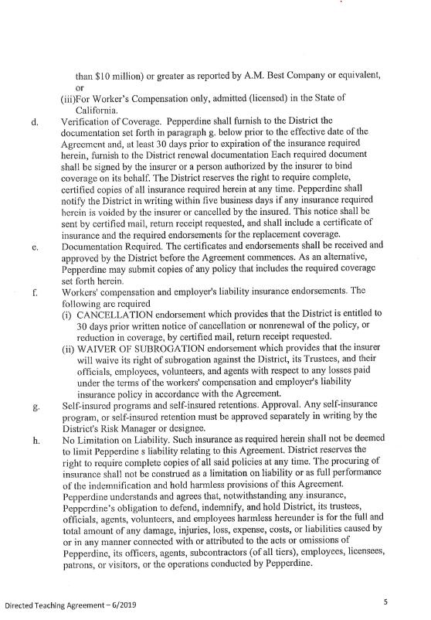 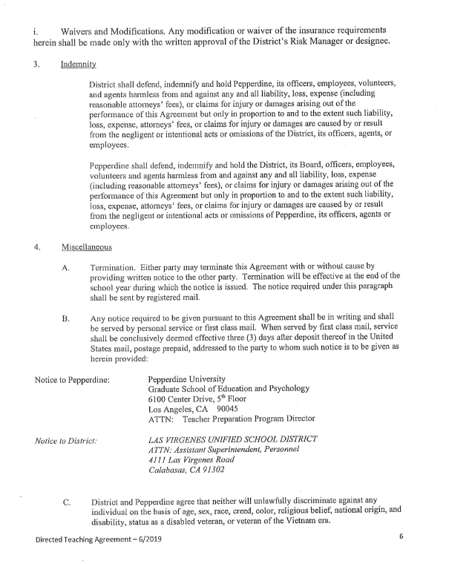 

This is another MOU sample with Lynwood Unified School District:

**DIRECTED TEACHING AGREEMENT**

This Agreement is made between Pepperdine University ("Pepperdine") on behalf of Pepperdine Teacher Preparation Programs and the hereinafter mentioned school district ("District"). It is the parties' intent that this agreement is a cooperative agreement for the benefit of the public and that entering into this agreement does not trigger any compliance or reporting obligation on the part of Pepperdine. This agreement does not in any way enlarge the University's obligations under federal or state law regulation.

RECITALSA. Pepperdine has established an approved program (the "Program") of directed teaching for training education students of the University;

1. Directed teaching experiences are a required and integral part of the Program;
2. Pepperdine desires the cooperation of **Lynwood Unified School District** in the training of students through the directed teaching experiences, which will provide a benefit to the public; and
3. Pursuant to the provisions of Section 44320 of the California Education Code, the governing board of a District is authorized to enter into agreements with any university or college accredited by the State Board of Education as a teacher education institution, to provide teaching experience through directed teaching to students enrolled in teacher education curricula of such institution; and
4. Any such agreement may provide for the payment in money or services for the services rendered by the District in an amount not to exceed the actual cost to the District of the services rendered by the District.

Now, therefore, it is mutually agreed between the parties hereto as follows:

SPECIAL PROVISIONS

DATE: **August 22, 2019**

PARTIES: Pepperdine University and **Lynwood Unified School District**

TERM: From August 22, 2019 to July 31, 2024.

CONTRACT SERVICES: Not to exceed three Clinical Experiences per year, per mentor.

RATE AND AMOUNT: $150 Master Teaching Stipend per student, per session of Clinical Observation of student by Master Teacher. $150 Master Teaching Stipend per student teacher, per session of directed mentoring for Clinical Experience.

METHOD OF PAYM ENT: Check one.

Stipend is to be paid directly to the District.

XXXX Stipend is to be paid directly to the Master Teacher.

**GENERAL TERMS**

1. Directed Teaching
   * The District shall provide teaching experience through directed teaching in schools and classes of the District, not to exceed the number of directed teaching assignments. Such directed teaching shall be provided in such schools or classes of the District, and under the direct supervision and instruction of such employees of the District, as the District and Pepperdine through their duly authorized representatives may agree upon.
   * The District may, for good cause, refuse to accept for directed teaching any student of Pepperdine assigned to directed teaching in the District. In such event, Pepperdine shall terminate the assignment of such student to the directed teaching program in the

District.

* + The term "directed teaching" as used herein and elsewhere in this Agreement means active participation in the duties and functions of classroom teaching under the direct supervision and instruction of employees of the District who hold valid clear teaching credentials issued by the California Commission on Teacher Credentialing authorizing them to serve as classroom teachers in the schools or classes in which the direct teaching is provided, and who have completed a minimum of three years successful teaching experience.
  + Pepperdine student teachers without emergency or substitute credentials may not be asked by the school districts to serve and be paid for substitute teaching. Such students are not regarded as properly certified and require full-time supervision. Those holding substitute or emergency credentials may substitute only for their master teacher when s/he is out ill; when it is determined by the principal that such substitution is in the best interest of the student teacher and the students in the classroom; only after the first four weeks of that student's first student teaching assignment; the student teacher is paid by the District; and the number of days is kept to a minimum.
  + Pepperdine will pay for the performance by the District of all services required to be performed by the District under this Agreement at the aforesaid rates for each session of part-time directed teaching or full-time directed teaching provided by the District pursuant to this Agreement.
  + The term "session of directed teaching" as used herein and elsewhere in this Agreement is considered to be a full day of directed teaching for five (5) days a week for a minimum of eight (8) weeks for elementary credential candidates (for this, the elementary credential candidates receives four (4) semester units of practice teaching credit) and six

(6) periods a day for five (5) days a week for a minimum of eight (8) weeks for secondary credential candidates (for this, the secondary credential candidates receive four (4) semester units of practice teaching credit). The credential candidate must complete two (2) sessions for a minimum total of sixteen (16) weeks.

* + An assignment of a Pepperdine student to directed teaching in classes of schools of the District shall be for one (1), two (2), or three (3) sessions as mutually agreed between Pepperdine and the District.
  + An assignment of a Pepperdine student to directed teaching in the District shall be deemed to be effective for the purposes of this Agreement as of the date the student presents to the proper authorities of the District the assignment papers or other documents provided by Pepperdine affecting such assignment, but no earlier than the date of such assignment as shown on such card or other documents.

1. In the event the assignment of a Pepperdine student to directed teaching is terminated by Pepperdine for any reason after the student has been in directed teaching and has been at the assignment for a minimum of two weeks, the District shall receive payment for the assignment on account of such student as though there had been no termination of the assignment. Said payment not to exceed $150 per student per session of terminated assignment.
2. If applicable, within a reasonable time following the close of each session of Pepperdine, the District shall submit an invoice in triplicate, to Pepperdine for payment, at $150 per student, per term, for all directed teaching provided by the District under and in accordance with this Agreement during said session. This process may be altered in writing according to individual district procedures as to how the invoicing will proceed.
3. Notwithstanding any other provision of this Agreement, Pepperdine shall not be obligated by this Agreement to pay the District any amount in excess of the total sum.
4. In accordance with California Education Code Section 44320(b), each credential candidate, prior to assignment to District, must obtain at his or her sole expense a "Certificate of Clearance", which includes a complete Live Scan Service. The University will ensure that students receive a Certificate prior to beginning their assignment in the district.
5. In accordance with California Education Code Section 49406, each credential candidate prior to assignment to District must obtain at his or her sole expense an examination, by a licensed physician or surgeon within the past 60 days to determine that he or she is free of active tuberculosis, or provide a current certificate that shows s/he is free of communicable tuberculosis prior to beginning their assignment in the District.
6. Minimum Insurance Requirements
   1. District. The District shall maintain insurance in full force and effect, at its sole expense, the following minimum insurance coverage or comparable program of self-insurance:
      1. Commercial General Liability (Minimum Requirement):

$1,000,000 Combined Single Limit

* + 1. Coverage: Premises/Operations

Liability Medical Payments Liability

Personal Injury Liability

* + 1. The District shall maintain in full force and effect, at its sole expense, Workers' Compensation and Employers Liability Insurance in a form and amount covering District's full liability under the Workers' Compensation Insurance and Safety Act of the State of California as amended from time to time. Coverage:

1. Statutory limits per State of California
2. Employers Liability

$1,000,000 Each Accident

$1,000,000 Each Employee

District shall provide University with 30 days written notice before cancellation, or any reduction or material change in coverage.

1. University shall maintain insurance in full force and effect, at its sole expense:
   1. Commercial General Liability (Minimum Requirement):

$2,000,000 General Aggregate

$1,000,000 Combined Single Limits

* 1. Coverage:

Premises/Operations Liability Medical Payments Liability Contractual Liability Personal Injury Liability

Independent Contractors

* 1. The University will maintain in full force and effect, at its sole expense Workers' Compensation and Employers Liability Insurance in a form and amount covering University's full liability under the Workers' Compensation Insurance and Safety Act of the State of California as amended from time to time. Coverage:
     1. Statutory limits per State of California
     2. Employers Liability

$1,000,000 Each Accident

$1,000,000 Each Employee

A certificate of general liability insurance with the District named as an additional insured shall be provided by Pepperdine University' Insurance and Risk Department to the District 30 days in advance of the commencement of this agreement.

The District will require 30 days written notice before cancellation, or any reduction or material change in coverage.

* + 1. Indemnity

District shall defend, indemnify and hold Pepperdine, its officers, employees and agents harmless from and against any and all liability, loss, expense (including reasonable attorneys' fees), or claims for injury or damages arising out of the performance of this Agreement but only in proportion to and to the extent such liability, loss, expense, attorneys' fees, or claims for injury or damages are caused by or result from the negligent or intentional acts or omissions of the District, its officers, agents, or employees.

Pepperdine shall defend, indemnify and hold the District, its officers, employees and agents harmless from and against any and all liability, loss, expense (including reasonable attorneys' fees), or claims for injury or damages arising out of the performance of this Agreement but only in proportion to and to the extent such liability, loss, expense, attorneys' fees, or claims for injury or damages are caused by or result from the negligent or intentional acts or omissions of Pepperdine, its officers, agents or employees.

1. Miscellaneous
   * Termination. Either party may terminate this Agreement with or without cause by providing written notice to the other part y. Termination will be effective at the end of the school year during which the notice is issued. The notice required under this paragraph shall be sent by registered mail.
   * Any notice required to be given pursuant to this Agreement shall be in writing and shall be served by personal service or first class mail. When served by first class mail, service shall be conclusively deemed effective three (3) days after deposit thereof in the United States mail, postage prepaid, addressed to the party to whom such notice is to be given as herein provided:

Notice to Pepperdine:

Notice to District:

Pepperdine University

Graduate School of Education and Psychology 6100 Center Drive, 5th Floor

Los Angeles, CA 90045

ATTN: Teacher Preparation Program Director

Lynwood Unified School District 11321 Bullis Road

Lynwood, CA 90262

Attn: Carlos Zaragoza, Director of Human Resources

1. District and Pepperdine agree that neither will unlawfully discriminate against any individual on the basis of age, sex, race, creed, color, religious belief, national origin, and disability, status as a disabled veteran, or veteran of the Vietnam era.
2. Neither party shall use the other's name or any corporate or business name which is reasonably likely to suggest that the two are related without first obtaining the written consent of the other party.
3. The Agreement constitutes the entire understanding between the parties with respect to the subject matter hereof and may be modified only by a writing signed by both parties.
4. The parties hereto shall not have either the power or the right to assign this Agreement or any part thereof to any person or party for any reason, and any attempt to do so shall be void and of no legal effect.
5. This Agreement shall be governed by and construed under the laws of the State of California, which shall be the forum for any lawsuit arising from or incident to this Agreement.
6. Should either party reasonably retain an attorney to enforce the terms of this Agreement, the prevailing party shall be entitled to recover reasonable attorney's fees and costs including fees and costs of corporate staff and counsel.
7. In the event that any provision of this Agreement shall be held void, voidable, or unenforceable, the remaining provisions of this Agreement shall remain in full force and effect in accordance with its terms disregarding such unenforceable or invalid provision.
8. Each party is an independent agent and shall not act as, or be an agent or employee of, the other party.

In witness thereof, the parties hereto have caused this Agreement to be signed by its duly authorized representative.

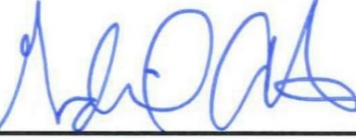

School District

Representative Gudiel R. Crosthwaite

Print Name Signature Date

Dr. Anthony Collatos,

Program Director 8/23/19

Print Name Signature Date

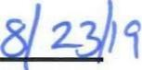

Directed Teaching Agreement -1/2019 6

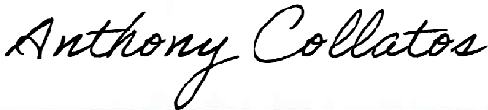

## Training Materials. Here are samples of our training materials, for both Pathways, Graduate & Undergraduate:

**University Field Supervisors Rubric**

|  |  |  |  |  |  |
| --- | --- | --- | --- | --- | --- |
| **Engaging and Supporting All Students in Learning (TPE 1)** | | | | | |
| **The teacher candidate:** | **TPE** | **Does Not Meet Requirements** | **Almost Meets Requirements** | **Meets Requirements** | **Exceeds Requirements** |
| **Provides instruction that makes connections to learners’ prior knowledge and experiences** | 1.1 | Does not help students make connections to their prior knowledge or experience. | Uses some content knowledge to activate students’ prior knowledge or help them make connections to their previous experience. | Clearly uses background knowledge in the content to help students make connections to their prior knowledge or experience. | Considers curriculum goals and the students’ needs in selecting appropriate tasks; scaffolds instruction according to students’ needs. |
| **Uses a variety of appropriate instructional strategies to meet the needs of all learners** | 1.4 | Uses a limited range of instructional models and strategies with little attention to whether these are appropriate or helpful in conveying content or addressing student needs. | May attempt to use a range of instructional models and strategies, and attemptsto address subject matter content essential to student learning. | Uses instructional models, strategies and resources that support student learning and meet subject matter requirements. | Uses multiple instructional models, strategies and resources to support and expand student learning. Appropriate and resourceful adaptations are made to communicate content requirements and address the diverse learning needs of students. |
| **Promote students' critical and creative thinking and analysis** | 1.5 | Does not promote students' critical and creative thinking and analysis. | Somewhat promotes students' critical and creative thinking and analysis. | Appropriately promotes students' critical and creative thinking and analysis. | Effectively and efficiently promotes students' critical and creative thinking and analysis. |
| **Creating and Maintaining Effective Environments for Student Learning (TPE 2)** | | | | | |
| **The teacher candidate:** | **TPE** | **Does Not Meet Requirements** | **Almost Meets Requirements** | **Meets Requirements** | **Exceeds Requirements** |
| **Creates a safe, positive learning environment based on respect, positive social interaction, active engagement in learning, and self-motivation** | 2.1 | Uses verbal and non-verbal interactions that are not positive, respectful, supportive, or motivating. Provides no opportunities for active learning experiences or for students to work in groups. Students are not required to assume responsibility for their own learning. | Provides some verbal and non-verbal interactions that are positive, respectful and supportive. Provides a few opportunities for active learning; provides limited opportunities for students to work together. Uses instructional strategies that rely heavily on external student motivation. | Uses verbal and non-verbal interactions that are mostly positive, supportive, and respectful. Provides opportunities active learning group work, and for students to assume responsibility for their own learning. | Uses verbal and non-verbal interactions that are all positive, supportive, and respectful. Provides multiple opportunities for active learning; creates opportunities for students to work in groups and assume responsibility for their own learning. Employs approaches that rely heavily on internal student motivation. |
| **Creates diverse and productive student learning environments** | 2.2 | Does not create diverse and productive student learning environments. | Somewhat creates diverse and productive student learning environments. | Creates diverse and productive student learning environments. | Creates strong and effective diverse and productive student learning environments. |
| **Understanding and Organizing Subject Matter for Student Learning (TPE 3)** | | | | | |
| **The teacher candidate:** | **TPE** | **Does Not Meet Requirements** | **Almost Meets Requirements** | **Meets Requirements** | **Exceeds Requirements** |
| **Demonstrates knowledge of subject matter and connects to the state standard** | 3.1 | Does not demonstrate knowledge of subject matter and/or does not connect the lesson to a state standard. | Somewhat demonstrates knowledge of subject matter and connects the lesson to a state standard. | Demonstrates knowledge of subject matter and connects the lesson to a state standard. | Clearly demonstrates knowledge of subject matter and connects the lesson to a state standard. |
| **Plans, designs, implements, and monitors instruction consistent with content and makes cross-disciplinary connections** | 3.3 | Does not plan, design, implement, and monitor instruction consistent with content and/or does not make cross-disciplinary connections. | Somewhat plans, designs, implements, and monitors instruction consistent with content and makes cross-disciplinary connections. | Plans, designs, implements, and monitors instruction consistent with content and makes meaningful cross-disciplinary connections. | Holistically plans, designs, implements, and monitors instruction consistent with content and makes meaningful cross-disciplinary connections. |
| **Creates and implements learning experiences that help build accurate conceptual understanding, content knowledge, and academic language** | 3.5 | Does not create or implement learning experiences that build accurate conceptual knowledge. | Creates and implements lessons that mostly provide guidance through a logical learning progression. | Creates and implements lesson experiences that effectively guide students through logical learning progressions, causes them to reflect on prior knowledge, and helps students make connections between prior experience and content. | Creates and implements lesson experiences that provide students with multiple representations, guidance through learning progression, and recognition of common misconceptions. Lesson implementation stimulates reflection of prior knowledge, builds connections between prior experiences and content and helps students master the academic language of the content area. |
| **Uses technology to engage students and support their learning** | 3.6 | Does not use technology to engage students or support their learning. | Somewhat uses technology to engage students and support their learning. | Intentionally uses technology to engage students and support their learning. | Intentionally uses technology to engage students and support their learning and promotes digital literacy in the lesson. |
| **Planning Instruction and Designing Learning Experiences for All Students (TPE 4)** | | | | | |
| **The teacher candidate:** | **TPE** | **Does Not Meet Requirements** | **Almost Meets Requirements** | **Meets Requirements** | **Exceeds Requirements** |
| **Provides access to the curriculum for all students** | 4.4 | Does not provide all students with access to the curriculum. | Provides most students with access to the curriculum but can strive to more effectively modify and accommodate the lesson for all students. | Uses developmentally, linguistically, culturally appropriate learning activities, instructional materials, and resources for all students. | Uses all tools intentionally, removes barriers, and creates opportunities for students to support each other in learning. |
| **Assessing Student Learning (TPE 5)** | | | | | |
| **The teacher candidate:** | **TPE** | **Does Not Meet Requirements** | **Almost Meets Requirements** | **Meets Requirements** | **Exceeds Requirements** |
| **Uses multiple methods of assessment to monitor progress; creates opportunities for students to demonstrate understanding in diverse ways** | 5.1 | Fails to monitor student progress toward learning objectives; does not provide opportunities for students to demonstrate understanding in diverse ways. | Provides pre-, formative, and summative assessments that are somewhat aligned with lesson objectives and occasionally differentiates assessment opportunities. | Uses constant pre-, formative, and summative assessments to monitor progress toward lesson objectives and adapts instruction; uses a variety of assessment tools. | Uses constant and varied pre-, formative, and summative assessments to monitor student progress toward learning objectives and to guide instruction; differentiates assessment opportunities to address students’ needs and strengths. |
| **Provides opportunities for learners to self-assess** | 5.3 | Does not provide opportunities for learners to self-assess. | Somewhat provides opportunities for learners to self-assess by stating expectations. | Communicates clear expectations for self-assessment. | Clearly explains and models examples of self assessment; demonstrates how to monitor and improve learning. Students are required to self-evaluate and to set goals based on assessment results. |
| **Developing as a Professional Educator (TPE 6)** | | | | | |
| **The teacher candidate:** | **TPE** | **Does Not Meet Requirements** | **Almost Meets Requirements** | **Meets Requirements** | **Exceeds Requirements** |
| **Self-evaluates the effects of his/her choices and actions on others** | 6.1 | Provides no evidence that personal reflections identifying strengths and areas for improvement are being used to guide instruction and professional behaviors | Provides some evidence that personal reflections identifying strengths and areas for improvement are being used to guide instruction and professional behaviors | Provides evidence that personal reflections identifying strengths and areas for improvement are being used to guide instruction and professional behaviors. | Provides substantial evidence that personal reflections identifying strengths and areas for improvement are being used to guide instruction and professional behaviors. |
| **Understands and enacts professional roles and educators' civic, social, and moral responsibilities** | 6.6 | Does not understand and/or enact professional responsibilities. | May understand professional responsibilities, but does not enact them. | Understands and enacts professional roles and educators' civic, social, and moral responsibilities. | Fully understands and enacts professional roles and educators' civic, social, and moral responsibilities. |

**Mentor Teacher Training Sessions/Agenda**

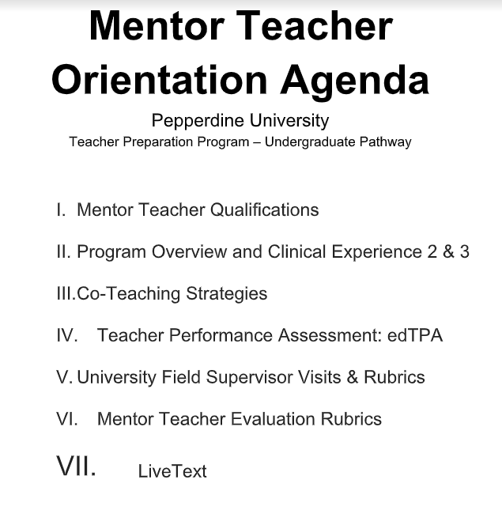

**Instructions to Login to the Assessment Management Software, LiveText**

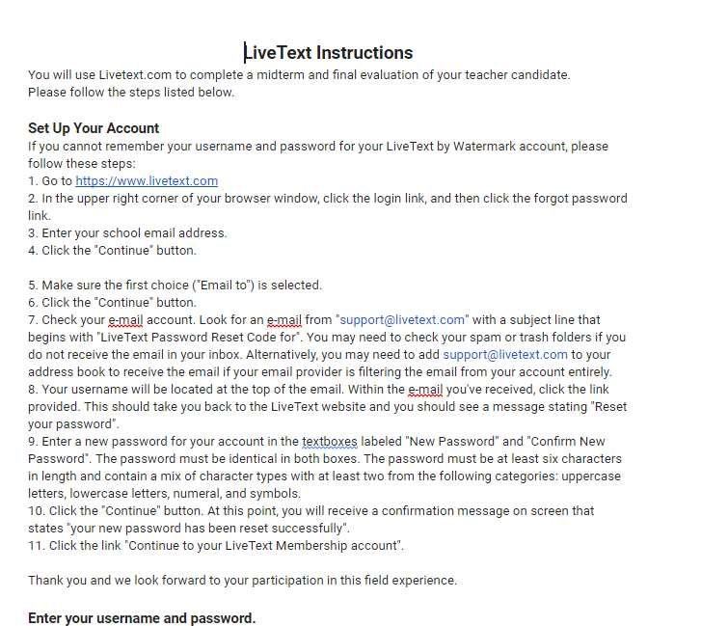

**Co-Teaching Structure**

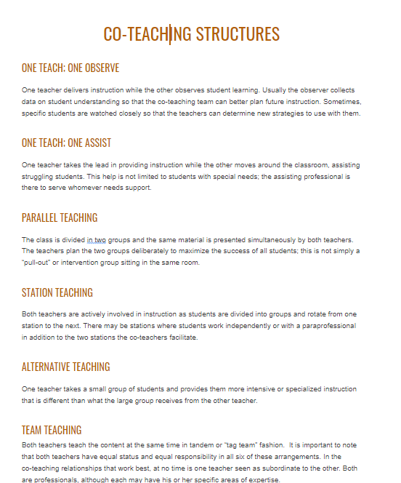

**Mentor Teacher Rubric**

**Mentor Teacher Assessment Rubric**

|  |  |  |  |  |
| --- | --- | --- | --- | --- |
|  | **Does Not Meet Requirements** | **Almost Meets Requirements** | **Meets**  **Requirements** | **Exceeds Requirements** |
| **Engaging and Supporting all Students in Learning**  **(TPE 1)** | The teacher candidate observes, but seems disengaged, does not support the mentor teacher effectively, and shows little interest in supporting the students. | The teacher candidate is working toward building rapport with students to further engage and support student learning. | The teacher candidate builds a positive rapport with students and effectively engages and supports them in learning tasks. The teacher candidate is focused on student learning and asks the mentor teacher questions to further learning. | The teacher candidate goes above and beyond to support and engage students in learning activities, as well as become part of the classroom community. The teacher candidate learns about the students individually as well as effectively identifies the academic levels of all students in the classroom. |
| **Creating and Maintaining Effective Environments for Student Learning**  **(TPE 2)** | The teacher candidate needs more guidance in the area of understanding the importance of fostering a caring, safe, inclusive classroom environment where each student is treated fairly and respectfully. The teacher candidate needs additional guidance in applying classroom management strategies to maintain an effective and engaging learning environment. | The teacher candidate is learning the importance of fostering a caring, safe, inclusive classroom environment where each student is treated fairly and respectfully. The teacher candidate is at a beginning level of applying classroom management strategies to maintain an effective and engaging learning environment. | The teacher candidate is aware of the importance of fostering a caring, safe, inclusive classroom environment where each student is treated fairly and respectfully. The teacher candidate strives to implement existing classroom management strategies to maintain an effective and engaging environment for student learning. | The teacher candidate participates in fostering a caring, safe, inclusive classroom environment where each student is treated fairly and respectfully. The teacher candidate effectively implements classroom management strategies to maintain an effective and engaging environment for student learning. |
| **Understanding and Organizing Subject Matter for Student Learning**  **(TPE 3)** | The teacher candidate shows little understanding of the current classroom curriculum and is currently unable to support students with diverse learning needs. | The teacher candidate is working toward understanding the current classroom curriculum and shows interest in learning more about differentiated instruction. | The teacher candidate strives to understand the current classroom curriculum and has a good understanding of the ways in which the subject matter is taught to student groups at various academic levels. | The teacher candidate appears to have a strong understanding of their subject matter and understands how differentiated instruction promotes student access to the curriculum. The teacher candidate provides instruction to the whole class and groups at various academic levels and facilitates a differentiated learning experience. |
| **Planning Instruction and Designing Learning Experiences for All Students  (TPE 4)** | The teacher candidate shows little interest in assisting the mentor teacher in preparing or planning for instruction. The teacher candidate needs a lot of support during lesson planning and whole class instruction. | The teacher candidate is working toward assisting the mentor teacher in planning and preparing for instruction. The teacher candidate is beginning to create lesson plans and beginning to lead whole class instruction. | The teacher candidate supports the mentor teacher in preparing for lessons and understanding daily planning and procedures. The teacher candidate plans and implements lessons effectively to whole class and small groups to provide direct and guided instruction with minimal assistance from the mentor teacher. | The teacher candidate takes initiative to support the mentor teacher in preparing for lessons and understanding daily planning and procedures. The teacher candidate plans and implements lessons effectively to whole class and small groups to provide direct and guided instruction. |
| **Assessing Student Learning**  **(TPE 5)** | The teacher candidate needs to improve in the area of assessment as depth of knowledge in the area of evaluation is lacking. | The teacher candidate understands the purpose and use of formative and summative assessments, but should gain greater depth of knowledge by facilitating and/or evaluating student assessments. | The teacher candidate understands the purpose and use of formative and summative assessments and often assists the mentor teacher with facilitating, creating, and evaluating student assessments. | The teacher candidate understands the purpose and use of formative and summative assessments and often assists the mentor teacher with facilitating, creating, and evaluating student assessments. |
| **Developing as a Professional Educator**  **(TPE 6)** | The teacher candidate needs improvement in the area of professional dress and attendance. The teacher candidate shows no interest in meeting with the teachers for a staff meeting or grade-level team meeting. | The teacher candidate should work toward the professional practice of appropriate dress, communication, and being punctual. The teacher candidate has missed many days of student teaching. The teacher candidate demonstrates minimal interest in attending staff meetings or grade-level team meetings. The practice of reflection appears to be underdeveloped. | The teacher candidate demonstrates professional behavior by communicating with the mentor teacher and being fairly reliable, punctual, and rarely absent. The teacher candidate demonstrates some interest in attending professional development sessions, such as grade-level team meetings or staff meetings, and is willing to attend IEP or 504 meetings (if invited). It is clear that the teacher candidate views reflection as essential to professional growth in the teaching profession. | The teacher candidate demonstrates professional behavior by clearly communicating with the mentor teacher and being consistently reliable, punctual, and rarely absent. When able, the teacher candidate attends professional development sessions, such as grade-level team meetings or staff meetings. The teacher candidate is eager to attend IEP or 504 meetings (if invited). It is clear that the teacher candidate views reflection as essential to professional growth in the teaching profession. |

edTPA PPTs and Informative Materials can be found here edTPA PPT

Snapshot of the few slides from a 26 deck can be seen below:

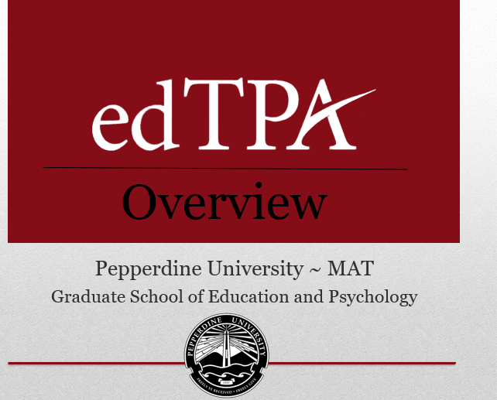

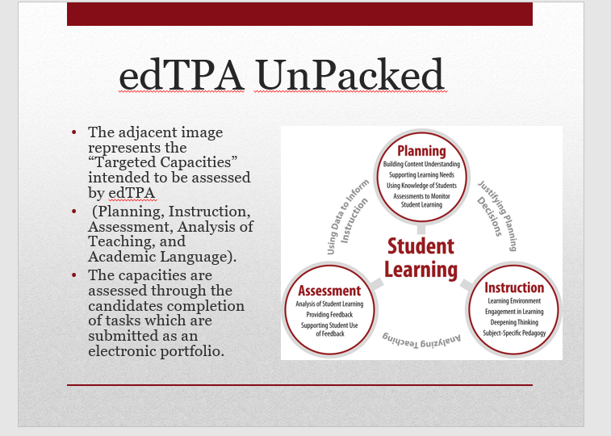

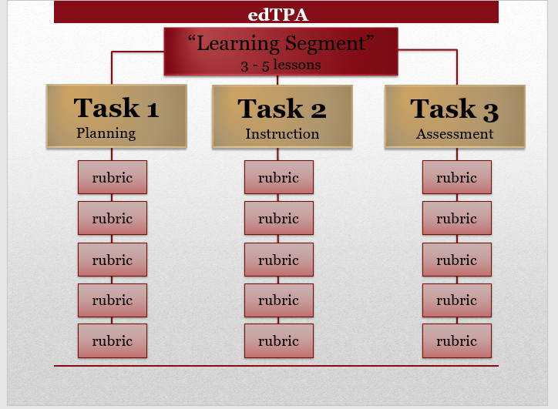

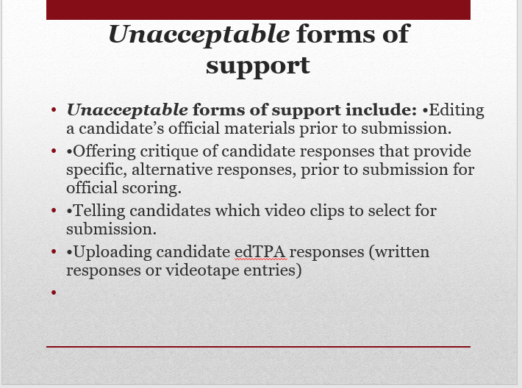

## Placement Spreadsheet/Table

Seaver College Placement Information

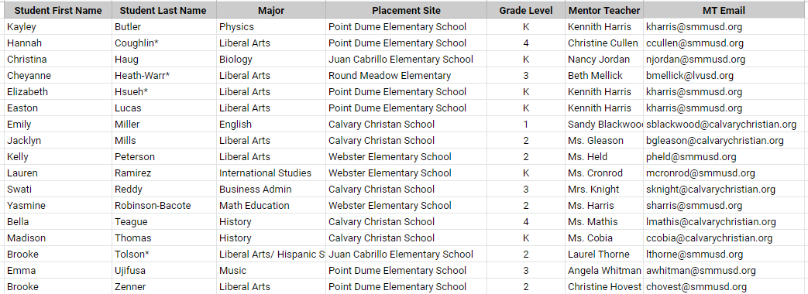

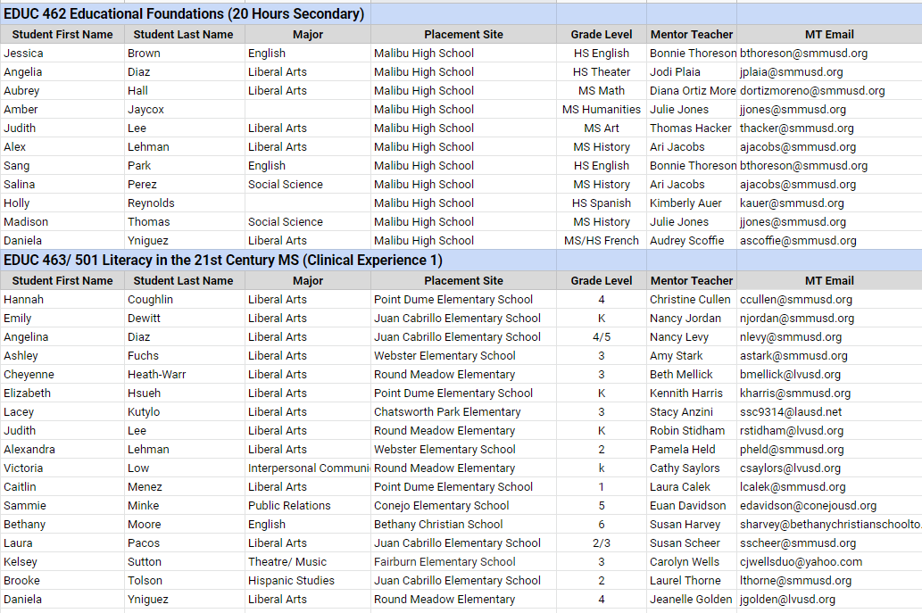

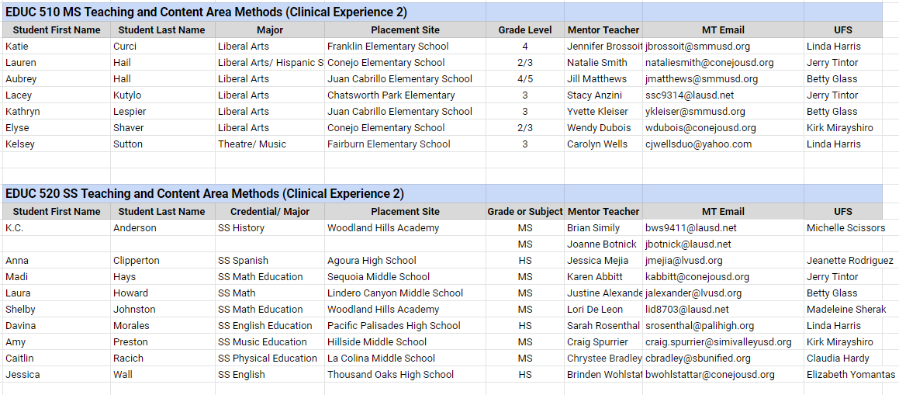

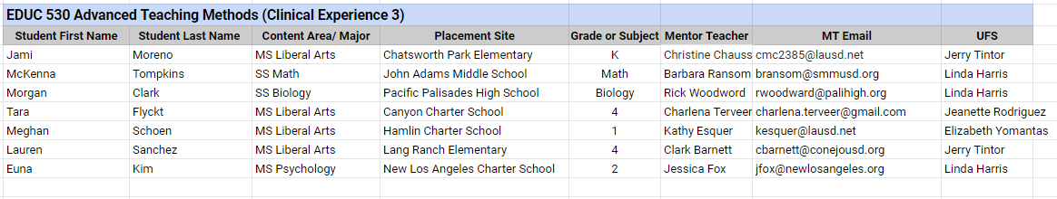

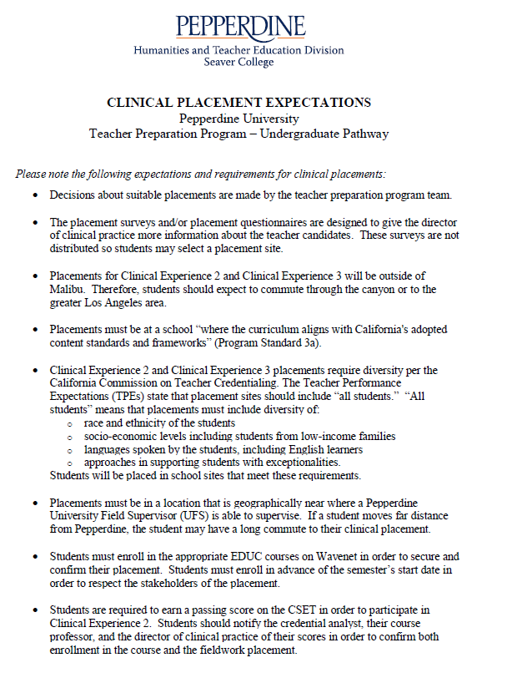

**GSEP Students Spring 2019 Placements**

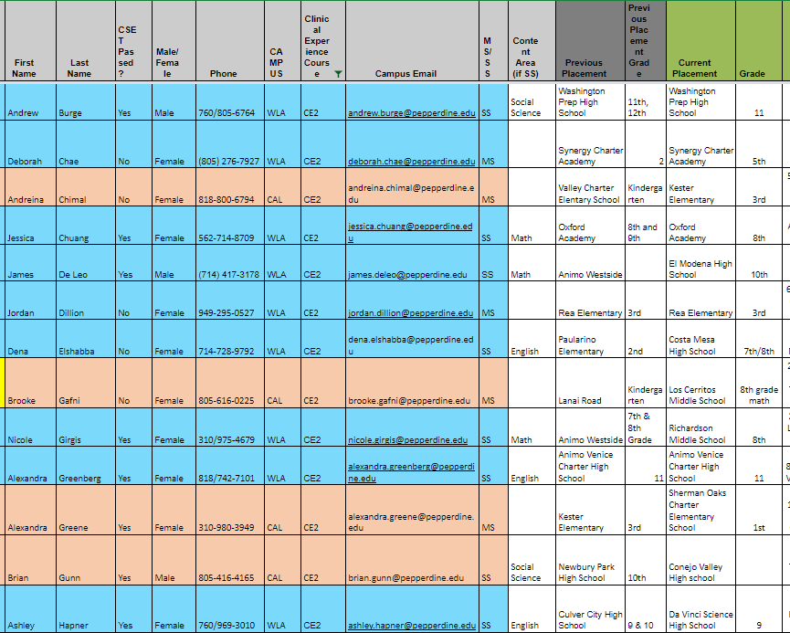

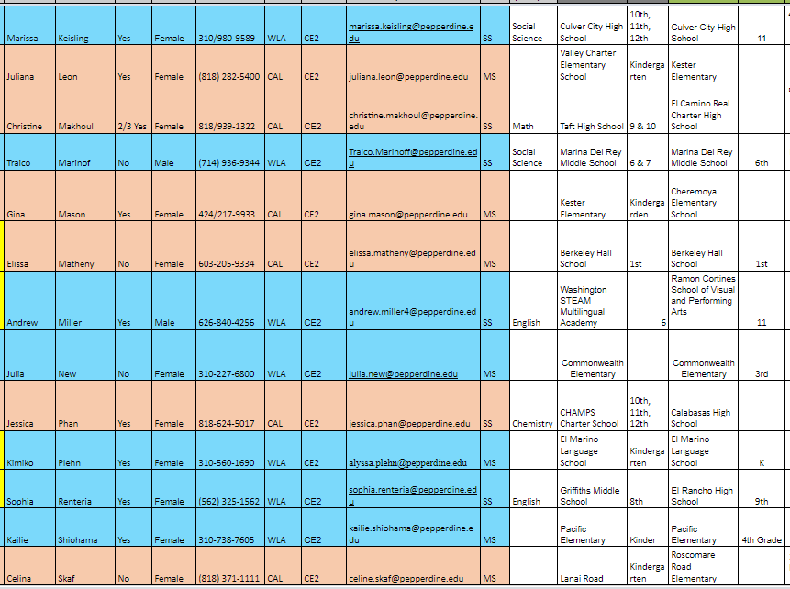

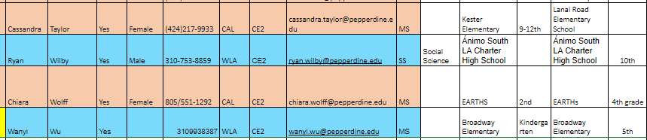

## Published Manuals or Handbooks or Advising Materials (links)

Please see excerpts from our TC Handbook on pg. 8, and consequently on pp. 25-26. Also, the link to the Handbook can be found here: [TC Handbook](http://../../../Shared%20drives/CTC%20TPP%20Accredidation%20Site%20Visit%20Documentation/Miscellaneous,%20Handbook,%20Docs,%20etc/TPP%20Handbook%202018-2019.pdf).

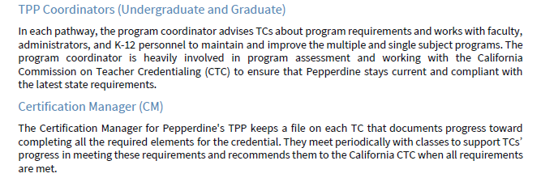

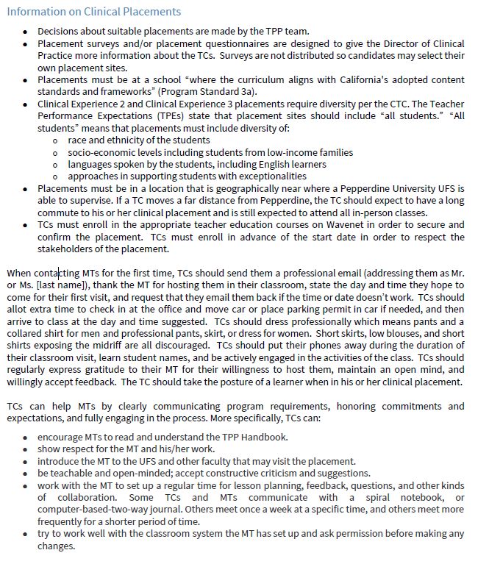

## Syllabi

Here are the syllabi for supervised clinical experiences, 3 from the Undergraduate Pathway and 3 from the Graduate Pathway.

Undergraduate Pathway

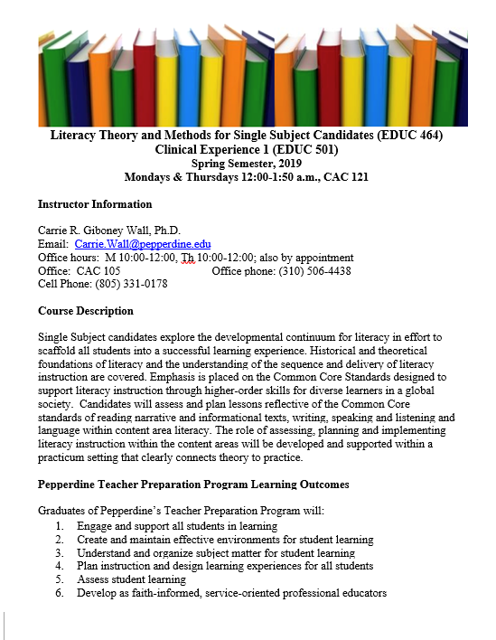

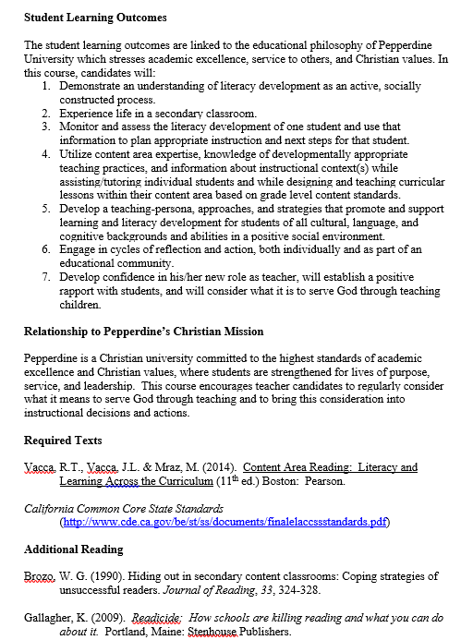

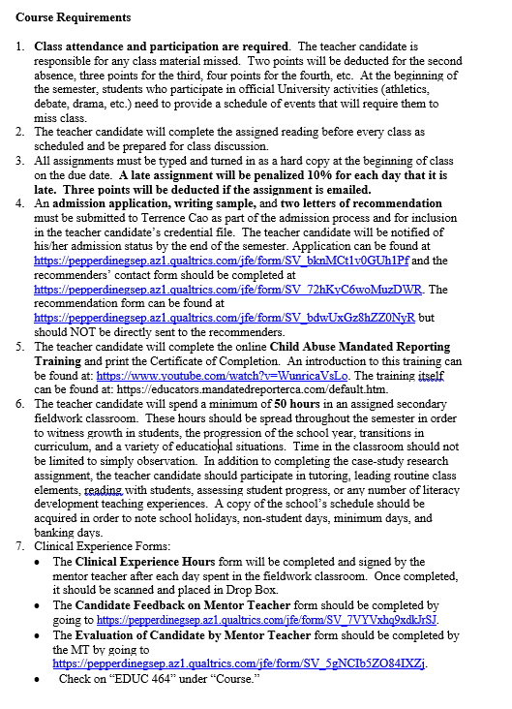 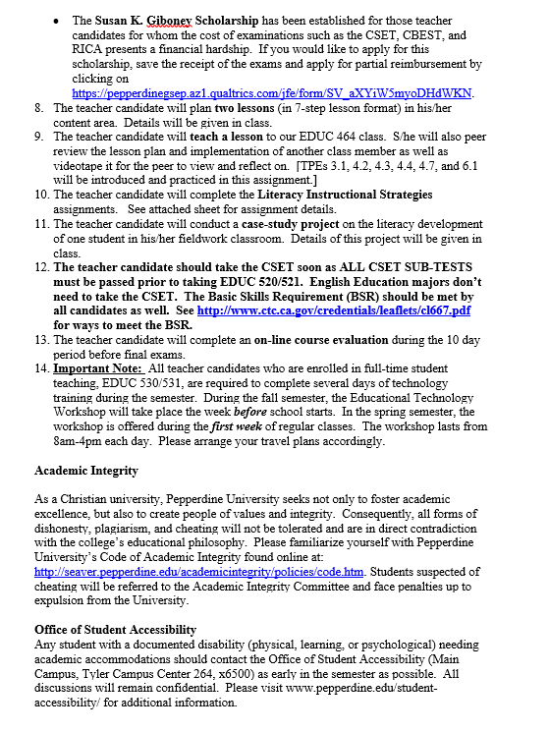 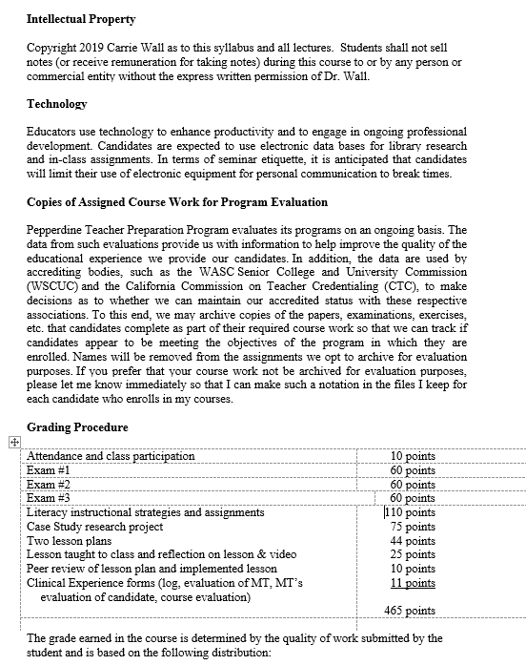 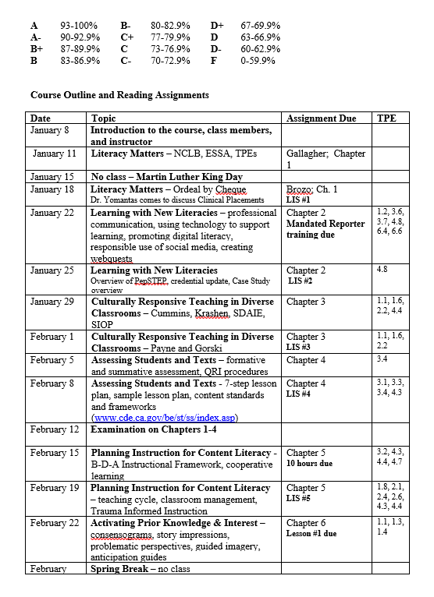 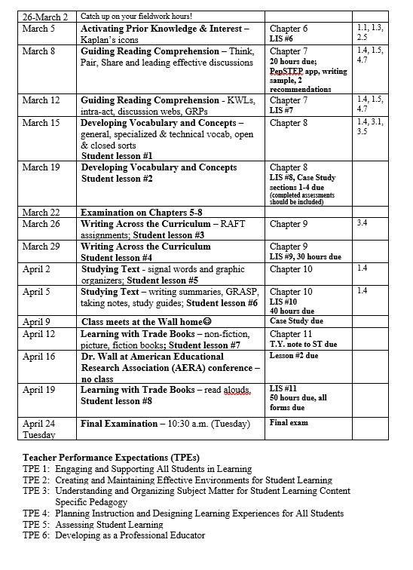 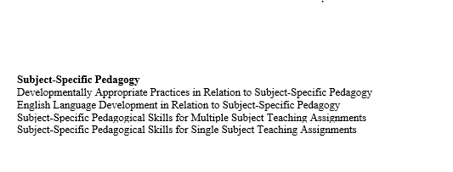

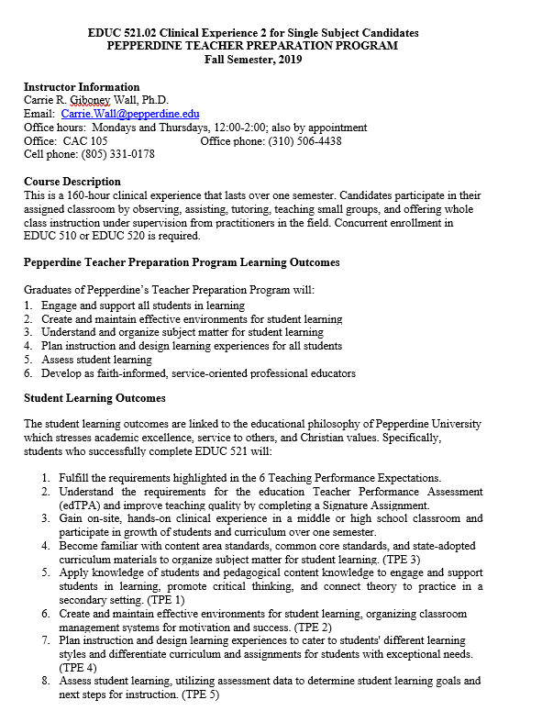 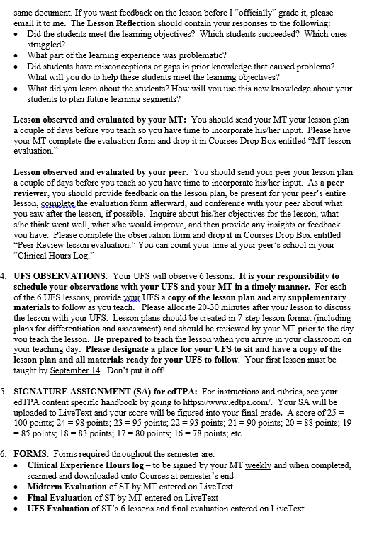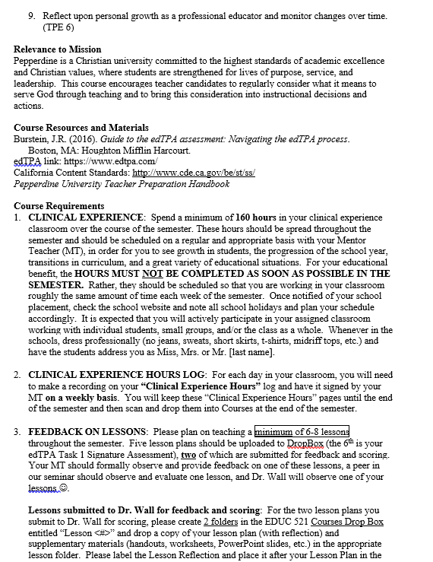 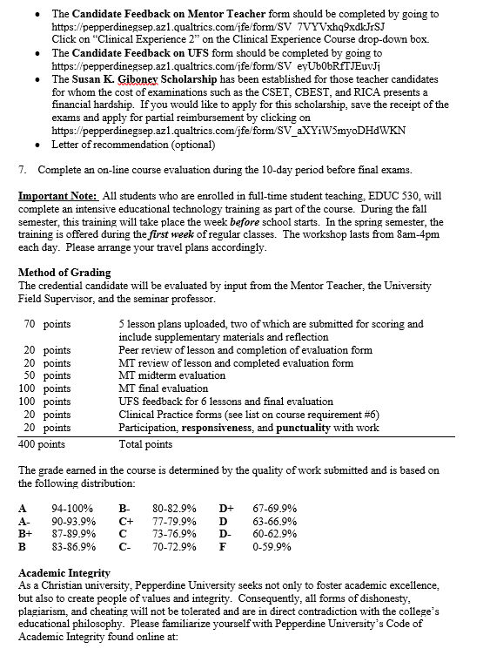 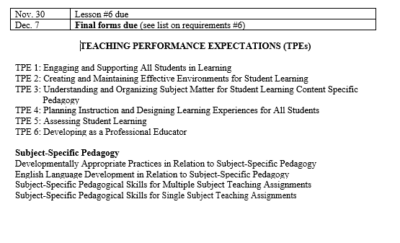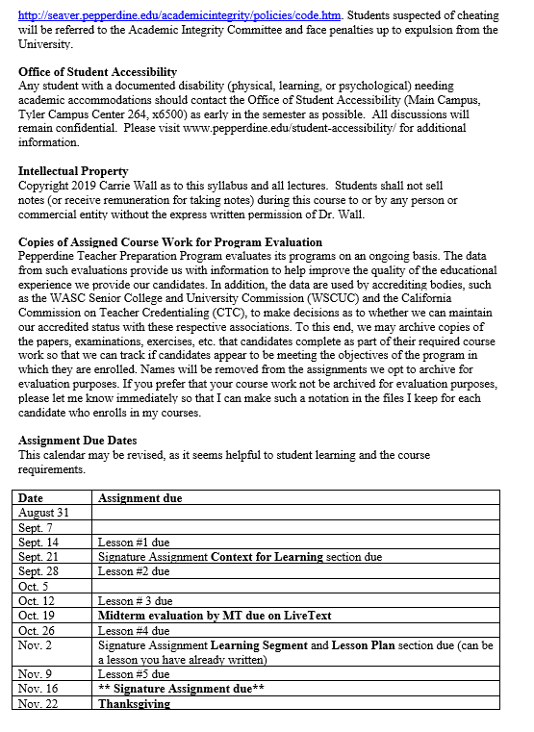

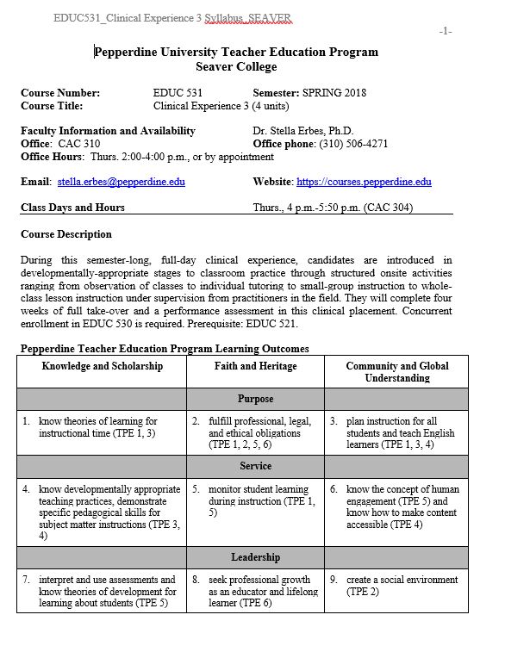

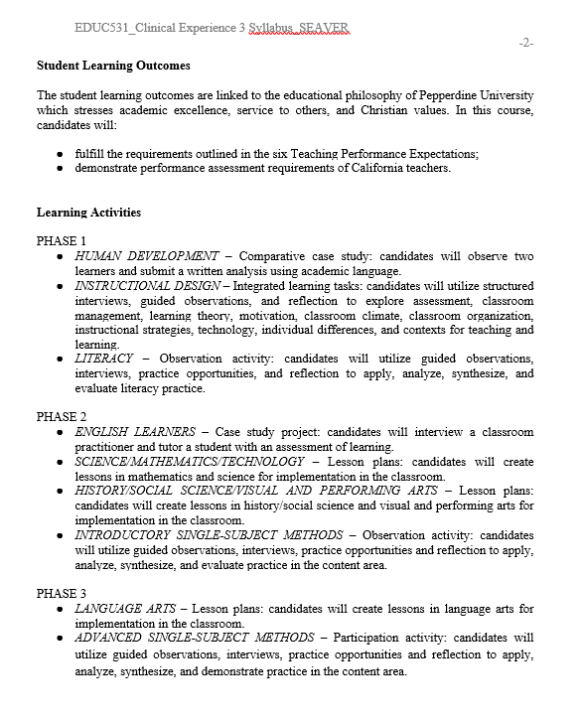

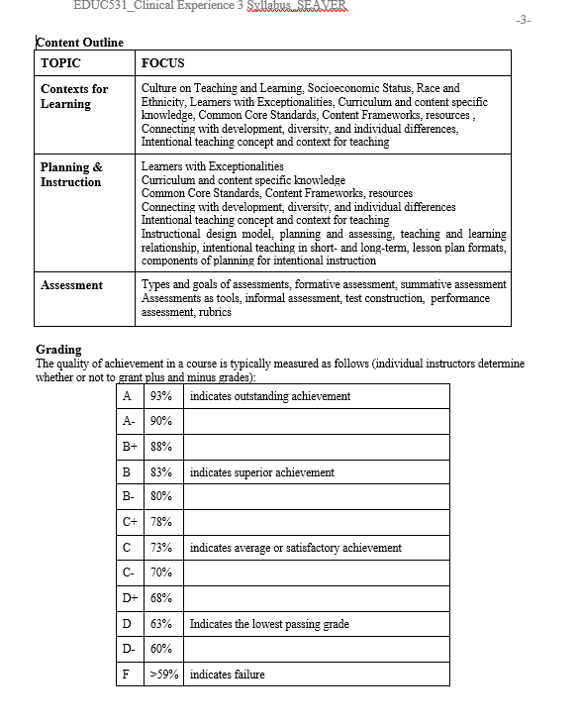

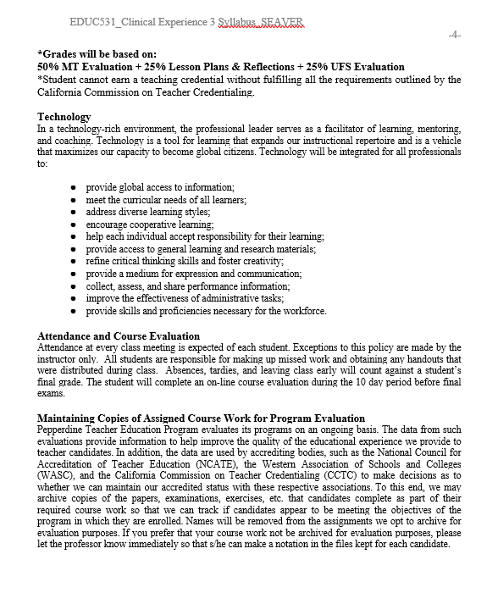

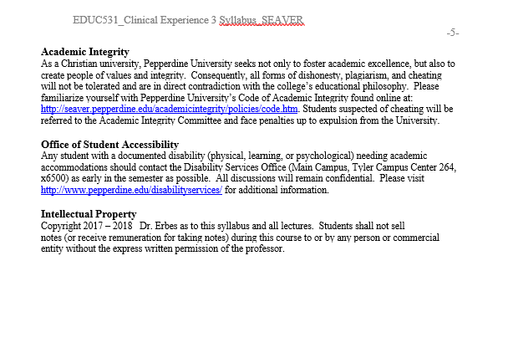

Graduate Pathway Syllabi

(Please see below screen shots of syllabi)

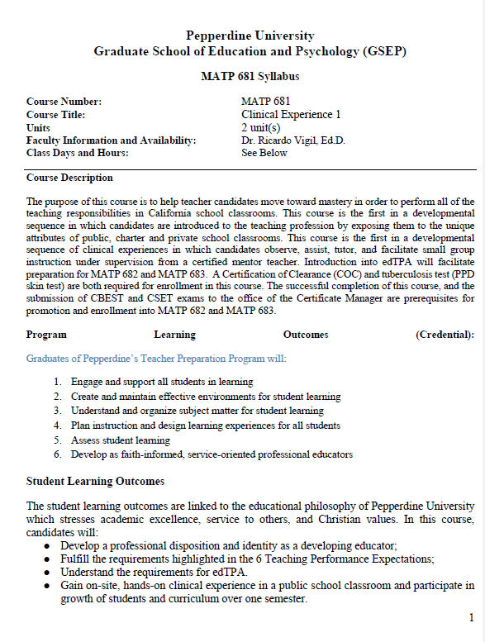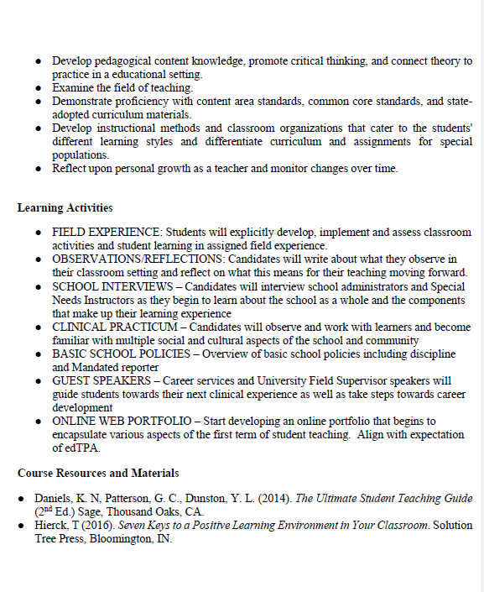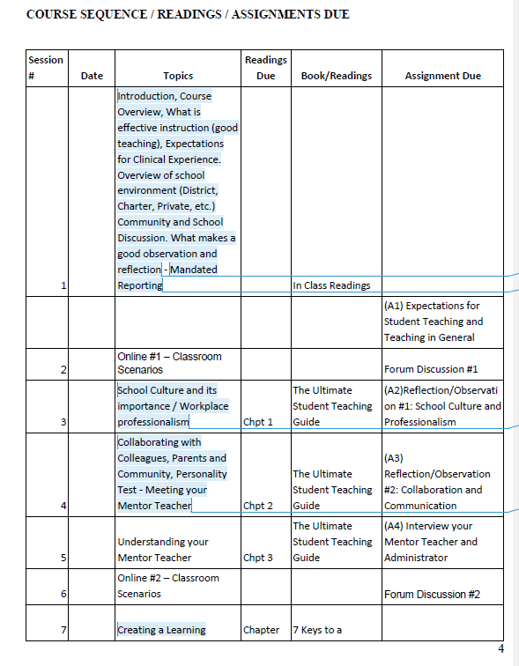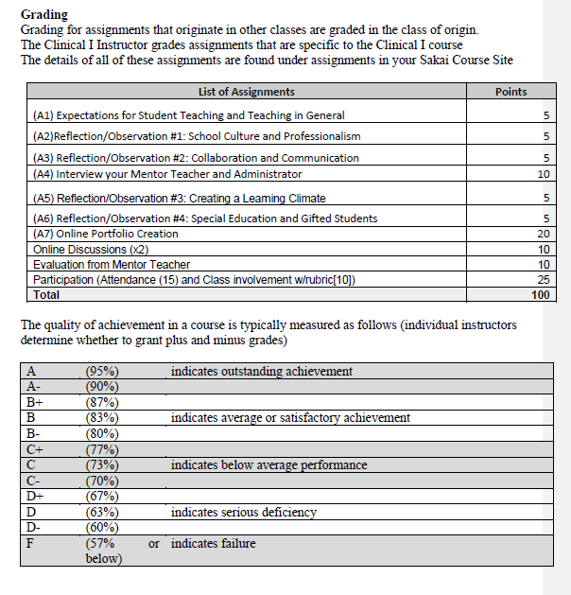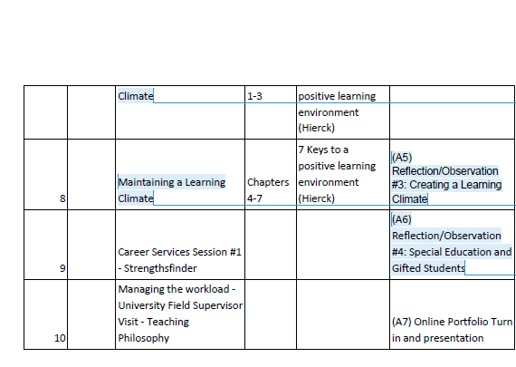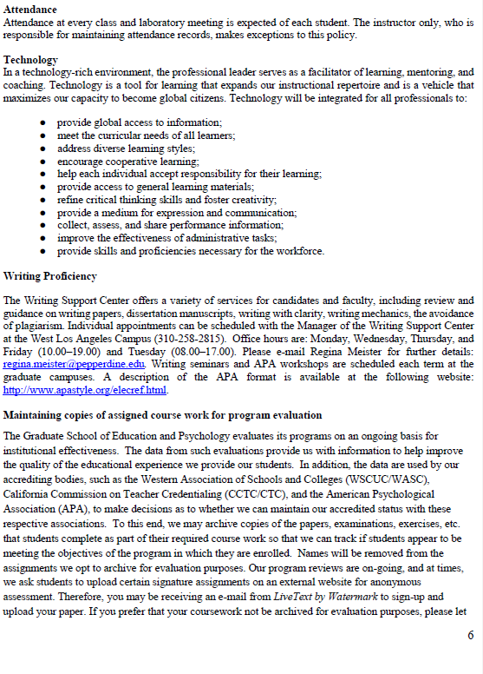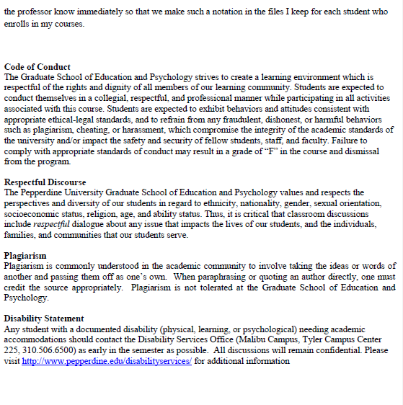

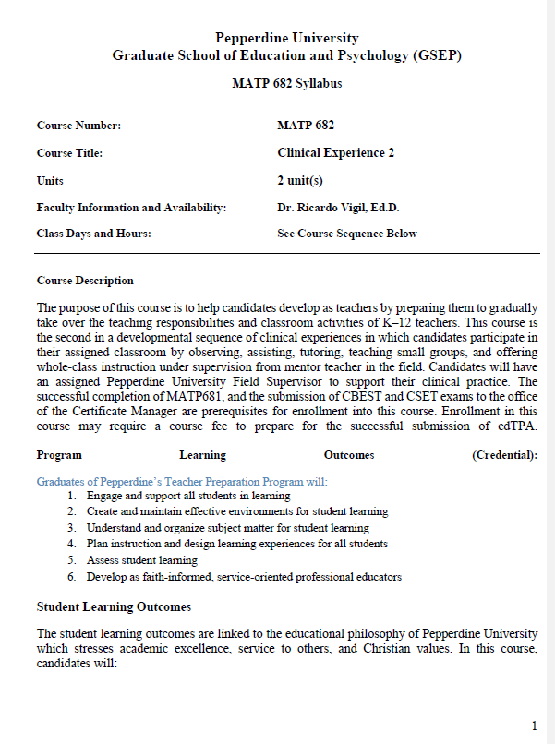 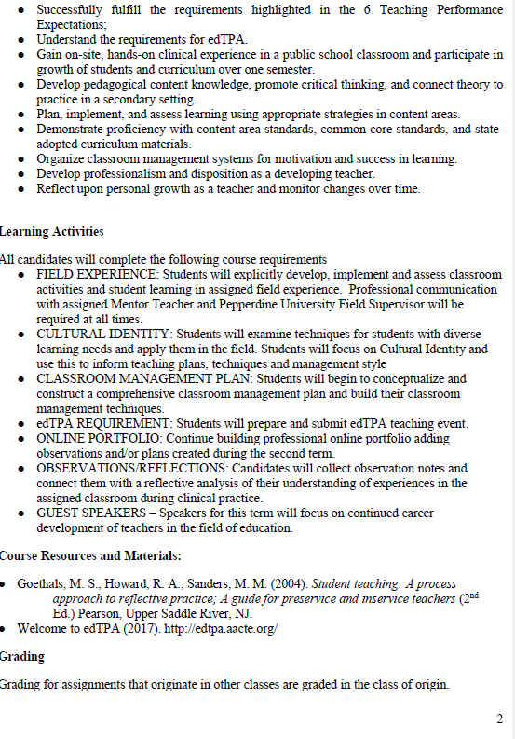 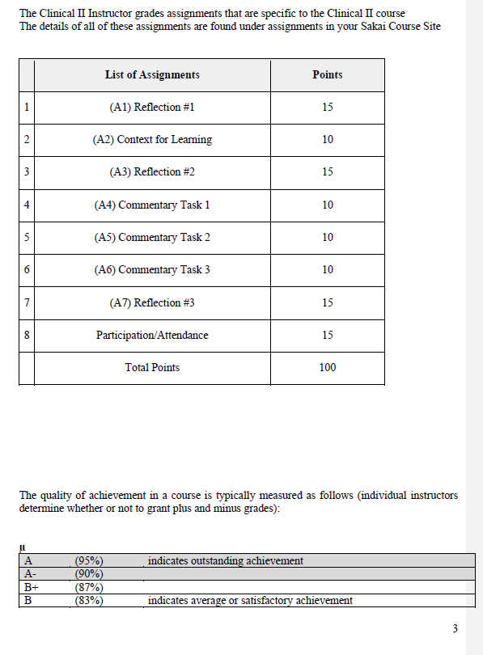 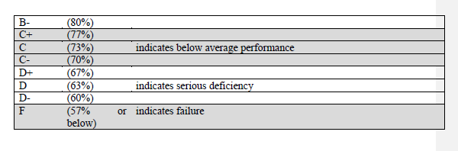 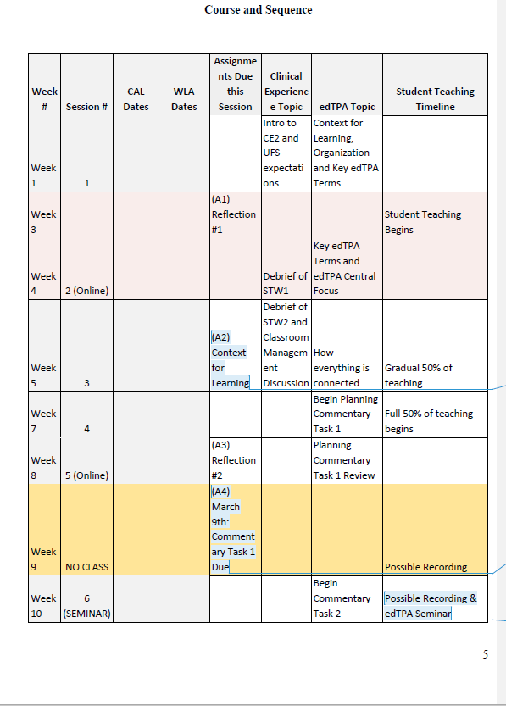 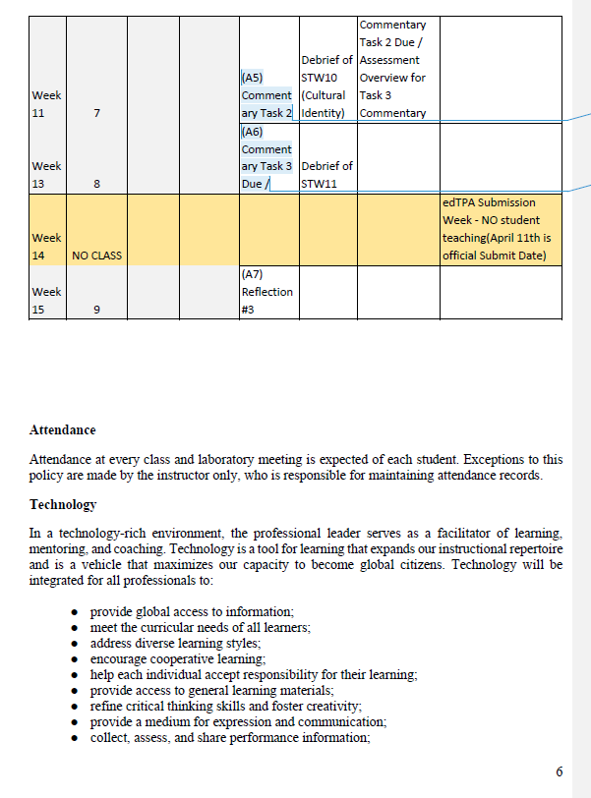 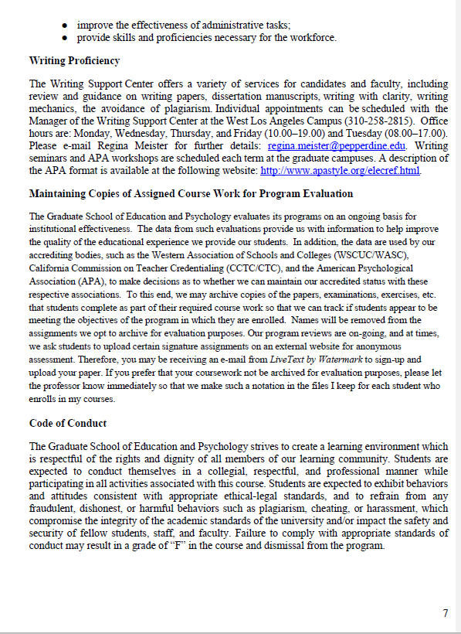

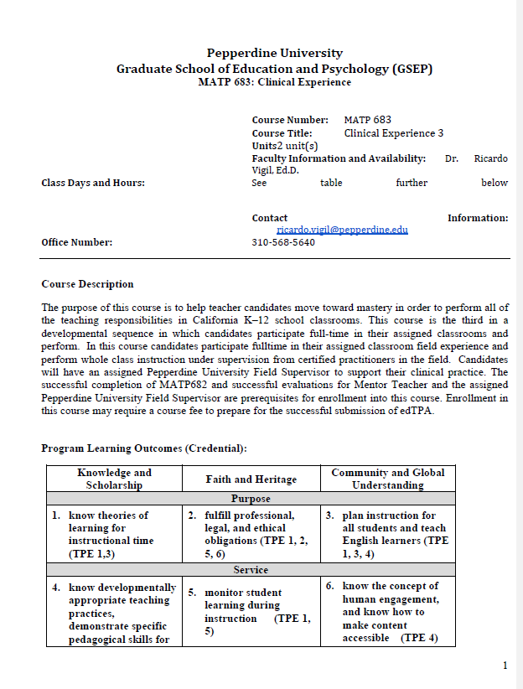 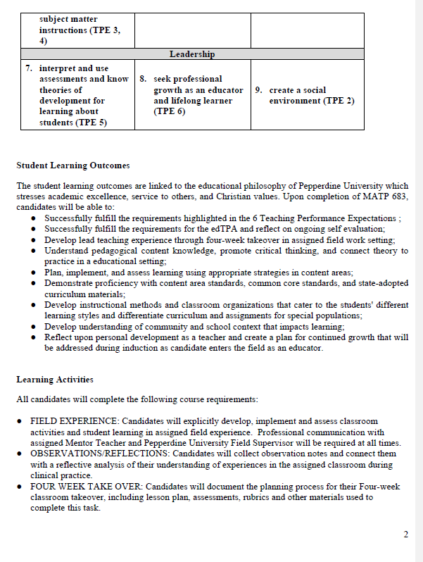 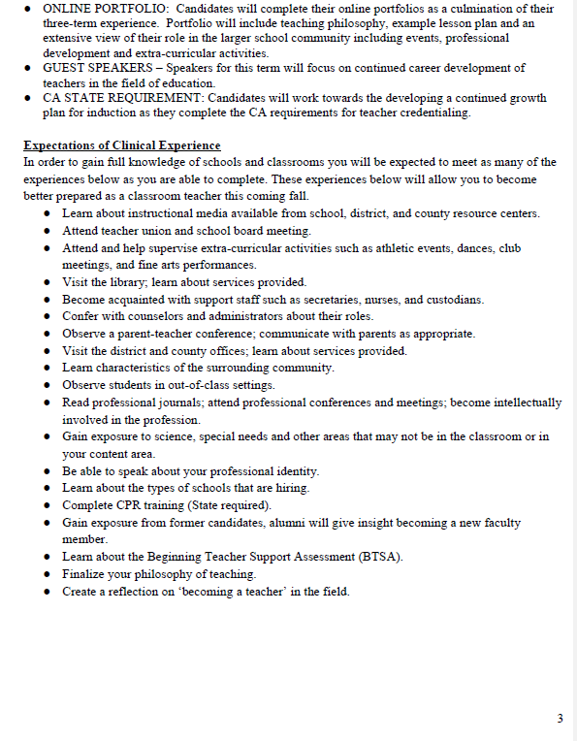 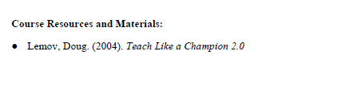 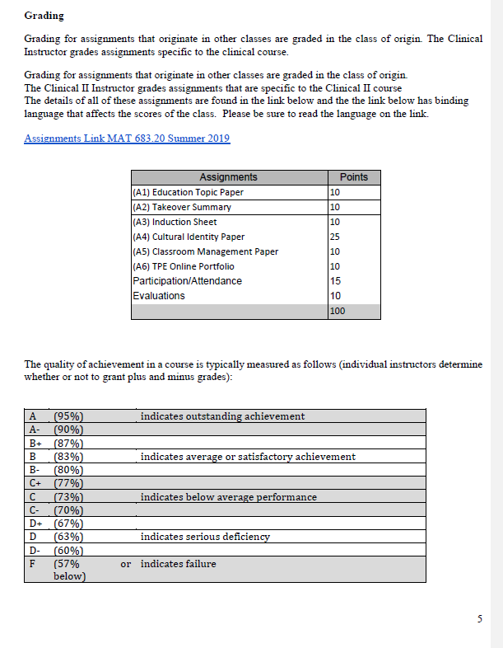 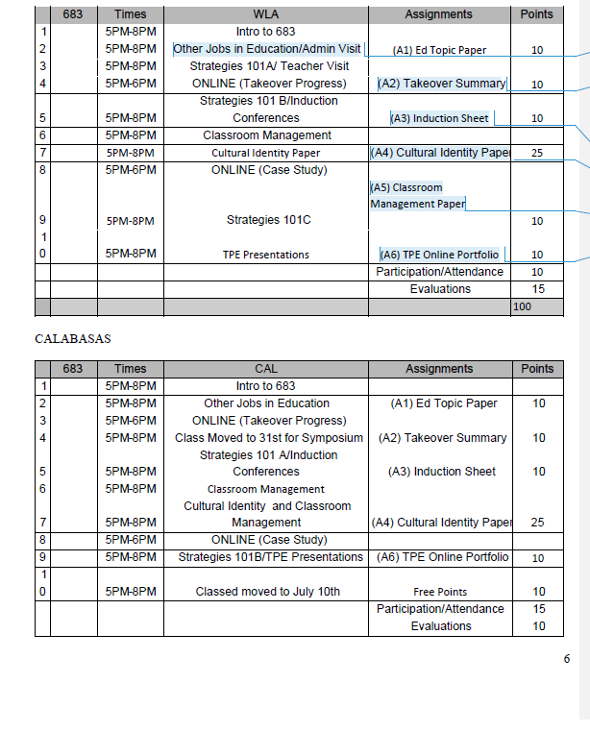 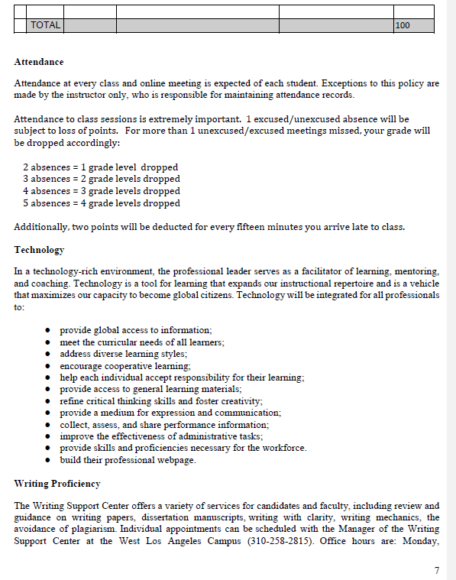 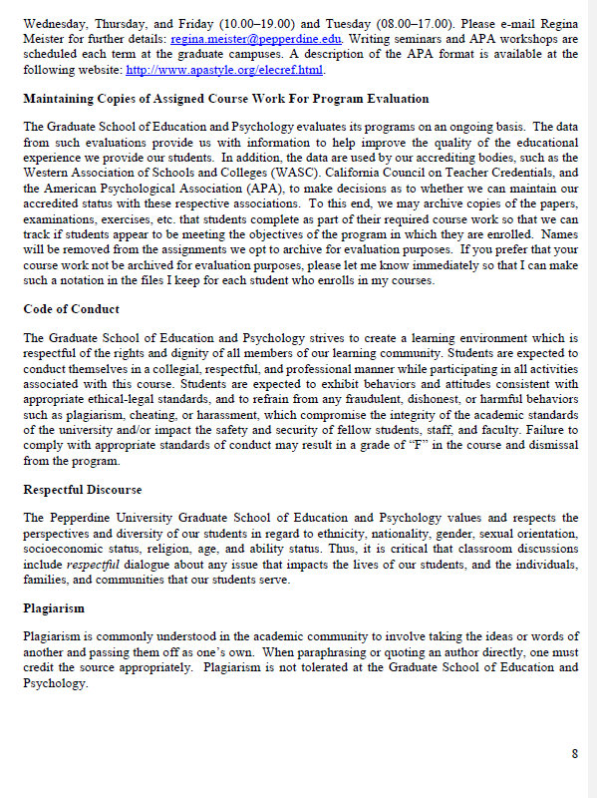 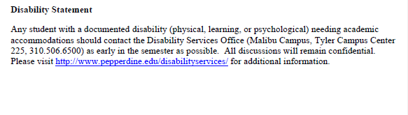

## Clinical Practice Assessment Instruments

University Field Supervisor Rubric

Candidate Name: ______________________________________ Date: __________________ Observation #: _____ School Site: ______________________________ Grade Level: _____________

|  |  |  |  |  |  |  |
| --- | --- | --- | --- | --- | --- | --- |
| **Engaging and Supporting All Students in Learning (TPE 1)** | | | | | |  |
| **The teacher candidate:** | **TPE** | **Does Not Meet Requirements** | **Almost Meets Requirements** | **Meets Requirements** | **Exceeds Requirements** |  |
| **Provides instruction that makes connections to learners’ prior knowledge and experiences** | 1.1 | Does not help students make connections to their prior knowledge or experience. | Uses some content knowledge to activate students’ prior knowledge or help them make connections to their previous experience. | Clearly uses background knowledge in the content to help students make connections to their prior knowledge or experience. | Considers curriculum goals and the students’ needs in selecting appropriate tasks; scaffolds instruction according to students’ needs. |  |
| **Uses a variety of appropriate instructional strategies to meet the needs of all learners** | 1.4 | Uses a limited range of instructional models and strategies with little attention to whether these are appropriate or helpful in conveying content or addressing student needs. | May attempt to use a range of instructional models and strategies, and attemptsto address subject matter content essential to student learning. | Uses instructional models, strategies and resources that support student learning and meet subject matter requirements. | Uses multiple instructional models, strategies and resources to support and expand student learning. Appropriate and resourceful adaptations are made to communicate content requirements and address the diverse learning needs of students. |  |
| **Promote students' critical and creative thinking and analysis** | 1.5 | Does not promote students' critical and creative thinking and analysis. | Somewhat promotes students' critical and creative thinking and analysis. | Appropriately promotes students' critical and creative thinking and analysis. | Effectively and efficiently promotes students' critical and creative thinking and analysis. |  |
| **Creating and Maintaining Effective Environments for Student Learning (TPE 2)** | | | | | |  |
| **The teacher candidate:** | **TPE** | **Does Not Meet Requirements** | **Almost Meets Requirements** | **Meets Requirements** | **Exceeds Requirements** |  |
| **Creates a safe, positive learning environment based on respect, positive social interaction, active engagement in learning, and self-motivation** | 2.1 | Uses verbal and non-verbal interactions that are not positive, respectful, supportive, or motivating. Provides no opportunities for active learning experiences or for students to work in groups. Students are not required to assume responsibility for their own learning. | Provides some verbal and non-verbal interactions that are positive, respectful and supportive. Provides a few opportunities for active learning; provides limited opportunities for students to work together. Uses instructional strategies that rely heavily on external student motivation. | Uses verbal and non-verbal interactions that are mostly positive, supportive, and respectful. Provides opportunities active learning group work, and for students to assume responsibility for their own learning. | Uses verbal and non-verbal interactions that are all positive, supportive, and respectful. Provides multiple opportunities for active learning; creates opportunities for students to work in groups and assume responsibility for their own learning. Employs approaches that rely heavily on internal student motivation. |  |
| **Creates diverse and productive student learning environments** | 2.2 | Does not create diverse and productive student learning environments. | Somewhat creates diverse and productive student learning environments. | Creates diverse and productive student learning environments. | Creates strong and effective diverse and productive student learning environments. |  |
| **Understanding and Organizing Subject Matter for Student Learning (TPE 3)** | | | | | |  |
| **The teacher candidate:** | **TPE** | **Does Not Meet Requirements** | **Almost Meets Requirements** | **Meets Requirements** | **Exceeds Requirements** |  |
| **Demonstrates knowledge of subject matter and connects to the state standard** | 3.1 | Does not demonstrate knowledge of subject matter and/or does not connect the lesson to a state standard. | Somewhat demonstrates knowledge of subject matter and connects the lesson to a state standard. | Demonstrates knowledge of subject matter and connects the lesson to a state standard. | Clearly demonstrates knowledge of subject matter and connects the lesson to a state standard. |  |
| **Plans, designs, implements, and monitors instruction consistent with content and makes cross-disciplinary connections** | 3.3 | Does not plans, design, implement, and monitor instruction consistent with content and/or does not make cross-disciplinary connections. | Somewhat plans, designs, implements, and monitors instruction consistent with content and makes cross-disciplinary connections. | Plans, designs, implements, and monitors instruction consistent with content and makes meaningful cross-disciplinary connections. | Holistically plans, designs, implements, and monitors instruction consistent with content and makes meaningful cross-disciplinary connections. |  |
| **Creates and implements learning experiences that help build accurate conceptual understanding, content knowledge, and academic language** | 3.5 | Does not create or implement learning experiences that build accurate conceptual knowledge. | Creates and implements lessons that mostly provide guidance through a logical learning progression. | Creates and implements lesson experiences that effectively guide students through logical learning progressions, causes them to reflect on prior knowledge, and helps students make connections between prior experience and content. | Creates and implements lesson experiences that provide students with multiple representations, guidance through learning progression, and recognition of common misconceptions. Lesson implementation stimulates reflection of prior knowledge, builds connections between prior experiences and content and helps students master the academic language of the content area. |  |
| **Uses technology to engage students and support their learning** | 3.6 | Does not use technology to engage students or support their learning. | Somewhat uses technology to engage students and support their learning. | Intentionally uses technology to engage students and support their learning. | Intentionally uses technology to engage students and support their learning and promotes digital literacy in the lesson. |  |
| **Planning Instruction and Designing Learning Experiences for All Students (TPE 4)** | | | | | |  |
| **The teacher candidate:** | **TPE** | **Does Not Meet Requirements** | **Almost Meets Requirements** | **Meets Requirements** | **Exceeds Requirements** |  |
| **Provides access to the curriculum for all students** | 4.4 | Does not provide all students with access to the curriculum. | Provides most students with access to the curriculum but can strive to more effectively modify and accommodate the lesson for all students. | Uses developmentally, linguistically, culturally appropriate learning activities, instructional materials, and resources for all students. | Uses all tools intentionally, removes barriers, and creates opportunities for students to support each other in learning. |  |
| **Assessing Student Learning (TPE 5)** | | | | | |  |
| **The teacher candidate:** | **TPE** | **Does Not Meet Requirements** | **Almost Meets Requirements** | **Meets Requirements** | **Exceeds Requirements** |  |
| **Uses multiple methods of assessment to monitor progress; creates opportunities for students to demonstrate understanding in diverse ways** | 5.1 | Fails to monitor student progress toward learning objectives; does not provide opportunities for students to demonstrate understanding in diverse ways. | Provides pre-, formative, and summative assessments that are somewhat aligned with lesson objectives and occasionally differentiates assessment opportunities. | Uses constant pre-, formative, and summative assessments to monitor progress toward lesson objectives and adapts instruction; uses a variety of assessment tools. | Uses constant and varied pre-, formative, and summative assessments to monitor student progress toward learning objectives and to guide instruction; differentiates assessment opportunities to address students’ needs and strengths. |  |
| **Provides opportunities for learners to self-assess** | 5.3 | Does not provide opportunities for learners to self-assess. | Somewhat provides opportunities for learners to self-assess by stating expectations. | Communicates clear expectations for self-assessment. | Clearly explains and models examples of self assessment; demonstrates how to monitor and improve learning. Students are required to self-evaluate and to set goals based on assessment results. |  |
| **Developing as a Professional Educator (TPE 6)** | | | | | |  |
| **The teacher candidate:** | **TPE** | **Does Not Meet Requirements** | **Almost Meets Requirements** | **Meets Requirements** | **Exceeds Requirements** |  |
| **Self-evaluates the effects of his/her choices and actions on others** | 6.1 | Provides no evidence that personal reflections identifying strengths and areas for improvement are being used to guide instruction and professional behaviors | Provides some evidence that personal reflections identifying strengths and areas for improvement are being used to guide instruction and professional behaviors | Provides evidence that personal reflections identifying strengths and areas for improvement are being used to guide instruction and professional behaviors. | Provides substantial evidence that personal reflections identifying strengths and areas for improvement are being used to guide instruction and professional behaviors. |  |
| **Understands and enacts professional roles and educators' civic, social, and moral responsibilities** | 6.6 | Does not understand and/or enact professional responsibilities. | May understand professional responsibilities but does not enact upon them. | Understands and enacts professional roles and educators' civic, social, and moral responsibilities. | Fully understands and enacts professional roles and educators' civic, social, and moral responsibilities. |  |

Mentor Teacher Rubric

**Mentor Teacher Assessment Rubric**

|  |  |  |  |  |
| --- | --- | --- | --- | --- |
|  | **Does Not Meet Requirements** | **Almost Meets Requirements** | **Meets**  **Requirements** | **Exceeds Requirements** |
| **Engaging and Supporting all Students in Learning**  **(TPE 1)** | The teacher candidate observes, but seems disengaged, does not support the mentor teacher effectively, and shows little interest in supporting the students. | The teacher candidate is working toward building rapport with students to further engage and support student learning. | The teacher candidate builds a positive rapport with students and effectively engages and supports them in learning tasks. The teacher candidate is focused on student learning and asks the mentor teacher questions to further learning. | The teacher candidate goes above and beyond to support and engage students in learning activities, as well as become part of the classroom community. The teacher candidate learns about the students individually as well as effectively identifies the academic levels of all students in the classroom. |
| **Creating and Maintaining Effective Environments for Student Learning**  **(TPE 2)** | The teacher candidate needs more guidance in the area of understanding the importance of fostering a caring, safe, inclusive classroom environment where each student is treated fairly and respectfully. The teacher candidate needs additional guidance in applying classroom management strategies to maintain an effective and engaging learning environment. | The teacher candidate is learning the importance of fostering a caring, safe, inclusive classroom environment where each student is treated fairly and respectfully. The teacher candidate is at a beginning level of applying classroom management strategies to maintain an effective and engaging learning environment. | The teacher candidate is aware of the importance of fostering a caring, safe, inclusive classroom environment where each student is treated fairly and respectfully. The teacher candidate strives to implement existing classroom management strategies to maintain an effective and engaging environment for student learning. | The teacher candidate participates in fostering a caring, safe, inclusive classroom environment where each student is treated fairly and respectfully. The teacher candidate effectively implements classroom management strategies to maintain an effective and engaging environment for student learning. |
| **Understanding and Organizing Subject Matter for Student Learning**  **(TPE 3)** | The teacher candidate shows little understanding of the current classroom curriculum and is currently unable to support students with diverse learning needs. | The teacher candidate is working toward understanding the current classroom curriculum and shows interest in learning more about differentiated instruction. | The teacher candidate strives to understand the current classroom curriculum and has a good understanding of the ways in which the subject matter is taught to student groups at various academic levels. | The teacher candidate appears to have a strong understanding of their subject matter and understands how differentiated instruction promotes student access to the curriculum. The teacher candidate provides instruction to the whole class and groups at various academic levels and facilitates a differentiated learning experience. |
| **Planning Instruction and Designing Learning Experiences for All Students  (TPE 4)** | The teacher candidate shows little interest in assisting the mentor teacher in preparing or planning for instruction. The teacher candidate needs a lot of support during lesson planning and whole class instruction. | The teacher candidate is working toward assisting the mentor teacher in planning and preparing for instruction. The teacher candidate is beginning to create lesson plans and beginning to lead whole class instruction. | The teacher candidate supports the mentor teacher in preparing for lessons and understanding daily planning and procedures. The teacher candidate plans and implements lessons effectively to whole class and small groups to provide direct and guided instruction with minimal assistance from the mentor teacher. | The teacher candidate takes initiative to support the mentor teacher in preparing for lessons and understanding daily planning and procedures. The teacher candidate plans and implements lessons effectively to whole class and small groups to provide direct and guided instruction. |
| **Assessing Student Learning**  **(TPE 5)** | The teacher candidate needs to improve in the area of assessment as depth of knowledge in the area of evaluation is lacking. | The teacher candidate understands the purpose and use of formative and summative assessments, but should gain greater depth of knowledge by facilitating and/or evaluating student assessments. | The teacher candidate understands the purpose and use of formative and summative assessments and often assists the mentor teacher with facilitating, creating, and evaluating student assessments. | The teacher candidate understands the purpose and use of formative and summative assessments and often assists the mentor teacher with facilitating, creating, and evaluating student assessments. |
| **Developing as a Professional Educator**  **(TPE 6)** | The teacher candidate needs improvement in the area of professional dress and attendance. The teacher candidate shows no interest in meeting with the teachers for a staff meeting or grade-level team meeting. | The teacher candidate should work toward the professional practice of appropriate dress, communication, and being punctual. The teacher candidate has missed many days of student teaching. The teacher candidate demonstrates minimal interest in attending staff meetings or grade-level team meetings. The practice of reflection appears to be underdeveloped. | The teacher candidate demonstrates professional behavior by communicating with the mentor teacher and being fairly reliable, punctual, and rarely absent. The teacher candidate demonstrates some interest in attending professional development sessions, such as grade-level team meetings or staff meetings, and is willing to attend IEP or 504 meetings (if invited). It is clear that the teacher candidate views reflection as essential to professional growth in the teaching profession. | The teacher candidate demonstrates professional behavior by clearly communicating with the mentor teacher and being consistently reliable, punctual, and rarely absent. When able, the teacher candidate attends professional development sessions, such as grade-level team meetings or staff meetings. The teacher candidate is eager to attend IEP or 504 meetings (if invited). It is clear that the teacher candidate views reflection as essential to professional growth in the teaching profession. |

# 7. Credential Recommendation

## 7.1 Description of the process ensuring appropriate recommendation

To ensure that TCs are on-track with their program progress, the Pepperdine TPP utilizes Google Sheets for its Undergraduate (7.1.1 File 1) and Graduate pathways (7.1.1 File 2) as well as PeopleSoft Checklists (7.1.1 File 3) to keep track of documents and follow up wherever needed. These documents categorize TCs by progress within the program, indicate assessment results, and mark notes for situations such as academic probation or advising holds.

TCs must maintain a GPA of at least 2.5 and earn a “C” or better in their classes to qualify for progress within the program. In addition, all TCs are subject to rigorous teaching evaluations by Mentor Teachers and University Field Supervisors which impact their grade in clinical experience classes. Furthermore, TCs are held accountable to the Pepperdine TPP Ethical Standards. All infringements are documented and managed by an impartial disciplinary committee comprised of the Dean of Education, faculty, and staff. Finally, the Pepperdine TPP holds students to deadlines for submitting credential-related documents such as TB tests or Intern Program applications. Failure to meet these deadlines results in consequences starting with delayed enrollment; repeated delays result in disciplinary action up to and including dismissal.

## 7.1.1. Candidate Progress Monitoring Documents

